**Industrial internship training**

**In Machine Learning with Python from**

**6 MONTHS**

**At**

**Solitaire Infosys pvt. Ltd. Mohali**



INTERNSHIP report BEING SUBMITTED by

**SAKSHI**

**INTERNSHIP REPORT SUBMITTED TO**

**Mr. ANCHAL SINGH**

ACKNOWLEDGEMENT

I greatly appreciate the guidance and academic support of my mentor whose contribution in suggestions and encouragements helped me complete my internship tasks in a convincing manner in all respects. I am awfully thankful to him for his painstaking efforts in arranging experimentation and open discussions on several programming topics that enabled this duration of internship a memorable opportunity ushered on to me for learning and sharing newer dimensions to my thinking process in software Engineering as a wonderful opportunity throughout.

In the end, I would like to thank Solitaire Infosys Pvt. Ltd , faculty and other Staff for arranging needful exposure to me during my internship.

**COMPANY PROFILE**

**Solitaire Infosys** private limited is a private incorporated on 6 june 2011. It is classified as non-govt. Company and registered at registrar of companies, Chandigarh its authorized share capital is Rs.900000 and its paid up capital is Rs.900000. It is involved in other computer related activities.

**Complete IT solution provider**

It is a leading software and web application development company, based in Mohali, which provides high quality comprehensive services to enterprises across wide range of platforms and technologies are major areas of expertise are in providing quality, cost effective software and web development.

Our focus is on understanding the diverse and mission critical need of each of our client to understand is to be able to deliver. The competence and experience of our company gives us a competitive edge by making sure we provide the best service and product to our clients. Our high quality standards unable us to deliver reliable and error free software application despite the complexity.

**Campus Edge**

Campus Edge is a beneficial campus resource planning software that helps institutes in a better functioning. The management, storage, and administration tasks get easier with our software. This ERP software will reduce our manual efforts and we will be able to maintain all our records more easily.

**Believe in Empowering Innovation through Technology**

Company design bilateral and interactive online experiences for their clients with vast knowledge of the latest industry trends and technologies.Company solution and service are created keeping in mine our client’s requirements & expectations and international standard as well.

**Company Expertise**

Solitaire Infosys helps enterprise, whether established or startups, to build and grow customer-centric digital products for mobile and web. Our clients trust our experience of our decade and our expertise that we have gained after numerous successful deliveries in various fields. We delivered satisfactory services to our clients with an aim of helping their business in growing and reaching their organizational goals.

**Our Vision**

We visualize becoming the most trusted and respected IT service provider across the globe with our vibrant, dynamic, and value-based IT solutions that revolve around our clients, team, and international standards. Solitaire Infosys Pvt. Ltd. envisions becoming a reliable partner to all its clients and focusing on doing everything ethically and rightly. We are always open to accept our mistakes and have the nerve to do the necessary changes.

**Our Goal**

To grow and flourish as a leading company, to be admired globally to provide atmost IT infrastructure and technical support services.

**Delivering great work experience to our clients is what we aim at.**

Solitaire Infosys Pvt. Ltd. Is an acclaimed IT service provider contributing its part in the development of many businesses around the globe. We socialize with our clients to get a superior cognizance of their business and requirements and help in fabricating websites and applications for their business. Founded in 2011 by a dynamic duo with the same aim and zeal, we have come a long way in satisfying our clients.

We are serving our clients with the world-class services for more than seven years now. The clients are delivered with the best IT solutions after we have developed a great understanding of their business and requirements. Our team works on the client projects like its own and that is the reason why we hold the edge in the league.

With every project that we deliver, we deliver our respect, creativity, quality, transparency, and teamwork to our clients. We have the experience, expertise, and capabilities to enable organizations to accelerate their service processes in every possible way. We are known for our excellent customer satisfaction, cost-effectiveness, and innovative skills that are unparalleled.

**Work**

How is working in solitaire Infosys special, find out about the work culture and career growth opportunities in solitaire Infosys at their office in Mohali. Follow them here and find out about their team, the fun and the work they do and stay updated with recruitment news and updates of solitaire Infosys.

**Looking for in youth**

As per the latest jobs posted by Solitaire Infosys they are regularly searching for job candidate with talents. They have latest openings. They freely communicated and hire fresher and experienced candidates who have filled their profiles and applied on their jobs at youth4work. What solitaire Infosys are looking for in the talents they add in their team is generally beyond just degrees and certificates but is the real passion for work a youth does. Which is generally seen by the details profiles of youth and talent matrix of youth?

**SOLITAIRE INFOSYS** is a leading software and web application development company, based in Mohali that provides high quality compressive services to enterprises across a wide range of platform and technologies. Our major areas of expertise are in providing quality, cost effective software or web development.

Our focus in own understanding the diverse and mission-critical needs of each of our clients. To understand is to be able to deliver. The competence and experience of our company gives us a competitive edge of making sure we provide the best services and products to our clients. Our high quality standard enables us to delivered reliable and errors-free software applications, despite their complexity.

We provide web design/web development, B2B&B2C E-commerce solutions, SEO &web promotions strategies implementation consulting services to both domestic as well as international clients‟ at the most affordable rates.

**Table of figures**

|  |  |  |
| --- | --- | --- |
| **Figure No.** | **Description** | **Page No.** |
| 1 | Anaconda Installation interface | 12 |
| 2 | Customization interface for installation | 13 |
| 3 | Anaconda installation interface | 13 |
| 4 | Final installation interface | 14 |
| 5 | Conditional decision flow diagram | 24 |
| 6 | If condition | 25 |
| 7 | If-else condition | 26 |
| 8 | Conditional looping diagram | 29 |
| 9 | While conditional looping | 30 |
| 10 | For looping | 31 |
| 11 | Break statement | 33 |
| 12 | Continue statement | 34 |
| 13 | Simple GUI | 47 |
| 14 | Notepad GUI | 48 |
| 15 | Simple sinusoidal plot | 49 |
| 16 | Parabolic plot | 50 |
| 17 | Overlaid plots | 50 |
| 18 | Bar plots | 9 |
| 19 | Histogram plots | 10 |
| 20 | Scatter plots | 20 |
| 21 | Image read output | 21 |
| 22 | Image Scaling | 22 |
| 23 | RGB image conversion to grey | 25 |
| 24 | Image read from Android-1 | 26 |
| 25 | Image read from Android-2 | 27 |
| 26 | Sample outputs of image converter | 29 |
| 27 | Machine learning process overview | 30 |
| 28 | Supervised learning process overview | 44 |
| 29 | Unsupervised learning process overview | 45 |
| 30 | Reinforcement learning process overview | 46 |
| 31 | Advantages of ML |  |
| 32 | Artificial intelligence overview |  |
| 33 | Students waiting for biometric attendance |  |
| 34 | Steps in digital signal processing |  |
| 35 | Haar-like features with different sizes and orientation |  |
| 36 | How the Haar like features are used to scale the eyes |  |
| 37 | Pixel coordinates of an integral image |  |
| 38 | Values of the image on the rectangle |  |
| 39 | Series of components |  |
| 40 | Logical design of the Desktop module Subsystems |  |
| 41 | The integral image |  |
| 42 | Sum Calculations |  |
| 43 | Types of features |  |
| 44 | The cascade classifier |  |
| 45 | Hardware Requirements |  |
| 46 | GUI Homepage |  |
| 47 | Sample Outputs |  |
| 48 | Marking attendance under normal conditions |  |
| 49 | Mark attendance under low light conditions |  |
| 50 | Data stored in the excel file |  |
| 51 | Data stored in the database |  |
|  |  |  |
|  |  |  |
|  |  |  |
|  |  |  |
|  |  |  |

# Chapter-1

**1.1 Introduction**

**1.1.1 Python Basic Theory**

Python is a widely used high-level programming language for general-purpose programming, created by Guido van Rossum and first released in 1991.

Python features a dynamic type system and automatic memory management and supports multiple programming paradigms, including object-oriented, imperative, functional programming, and procedural styles. It has a large and comprehensive standard library.

Two major versions of Python are currently in active use:

* Python 3.x is the current version and is under active development.
* Python 2.x is the legacy version and will receive only security updates until 2020.

No new features will be implemented. Note that many projects still use Python 2, although migrating to Python 3 is getting easier.

In addition, some third-parties offer re-packaged versions of Python that add commonly used libraries and other features to ease setup for common use cases, such as **math, data analysis** **or scientific** use.

**1.1.2 Why to Learn Python?**

* Python is a high-level, interpreted, interactive and object-oriented scripting language.
* Python is designed to be highly readable.
* It uses English keywords frequently where as other languages use punctuation, and it has fewer syntactical constructions than other languages.
* Python is a MUST for students and working professionals to become a great Software Engineer especially when they are working in Web Development Domain.

**1.1.3 Key advantages of learning Python:**

* **Python is Interpreted** − Python is processed at runtime by the interpreter. We do not need to compile your program before executing it. This is similar to PERL and PHP.
* **Python is Interactive** − we can actually sit at a Python prompt and interact with the interpreter directly to write your programs.
* **Python is Object-Oriented** − Python supports Object-Oriented style or technique of programming that encapsulates code within objects.
* **Python is a Beginner's Language** − Python is a great language for the beginner-level programmers and supports the development of a wide range of applications from simple text processing to WWW browsers to games.

**1.2 Characteristics of Python**

* It supports functional and structured programming methods as well as OOP.
* It can be used as a scripting language or can be compiled to byte-code for building large applications.
* It provides very high-level dynamic data types and supports dynamic type checking.
* It supports automatic garbage collection.
* It can be easily integrated with C, C++, COM, ActiveX, CORBA, and Java.

**1.3 Features of Python**

* **Easy-to-learn** − Python has few keywords, simple structure, and a clearly defined syntax. This allows the student to pick up the language quickly.
* **Easy-to-read** − Python code is more clearly defined and visible to the eyes.
* **Easy-to-maintain** − Python's source code is fairly easy-to-maintain.
* **A broad standard library** − Python's bulk of the library is very portable and cross-platform compatible on UNIX, Windows, and Macintosh.
* **Interactive Mode** − Python has support for an interactive mode which allows interactive testing and debugging of snippets of code.
* **Portable** − Python can run on a wide variety of hardware platforms and has the same interface on all platforms.
* **Extendable** – We can add low-level modules to the Python interpreter. These modules enable programmers to add to or customize their tools to be more efficient.
* **Databases** − Python provides interfaces to all major commercial databases.
* **GUI Programming** − Python supports GUI applications that can be created and ported to many system calls, libraries and windows systems, such as Windows MFC, Macintosh, and the X Window system of Unix.
* **Scalable** − Python provides a better structure and support for large programs than shell scripting.

**Chapter-2**

**2.1 Installation of Integrated development system**

During my internship period I entirely worked on Jupyter Notebook (IDE for python) which comes under the full package of Anaconda.

Here is how to get started with Anaconda System:

1. [Download the Anaconda installer](https://www.anaconda.com/download/#windows).
2. Double click the installer to launch.
3. Click Next.
4. Read the licensing terms and click “I Agree”.
5. Select an install for “Just Me” unless you’re installing for all users (which requires Windows Administrator privileges) and click Next.
6. Select a destination folder to install Anaconda and click the Next button.

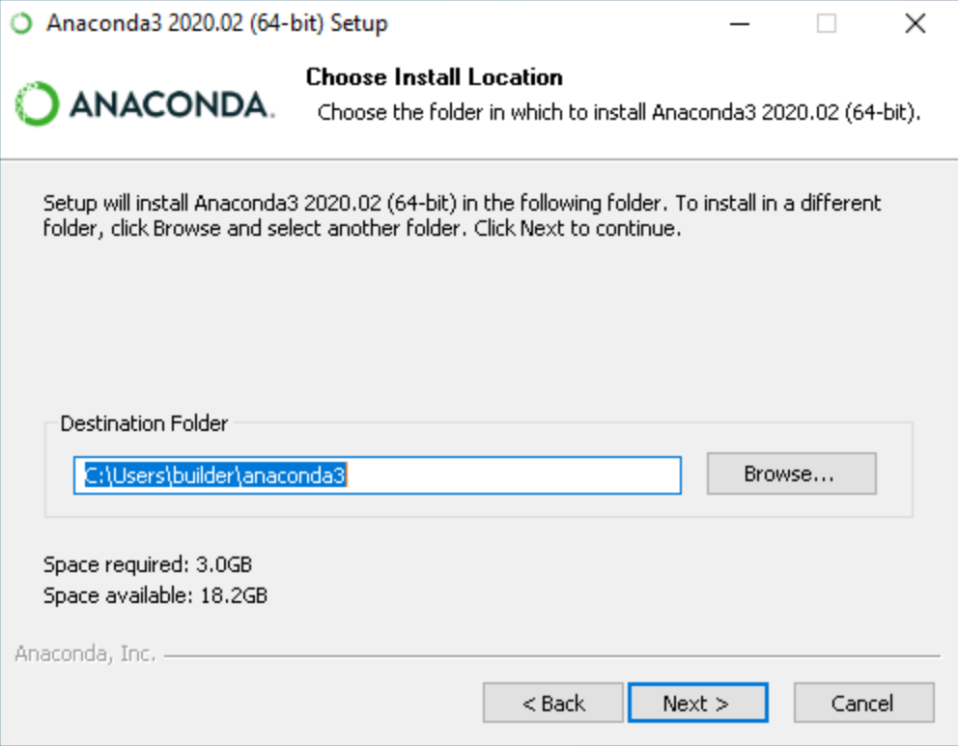

Figure-1: Anaconda installation interface

1. Choose whether to add Anaconda to your PATH environment variable. I recommend not adding Anaconda to the PATH environment variable, since this can interfere with other software. Instead, use Anaconda software by opening Anaconda Navigator or the Anaconda Prompt from the Start Menu.

[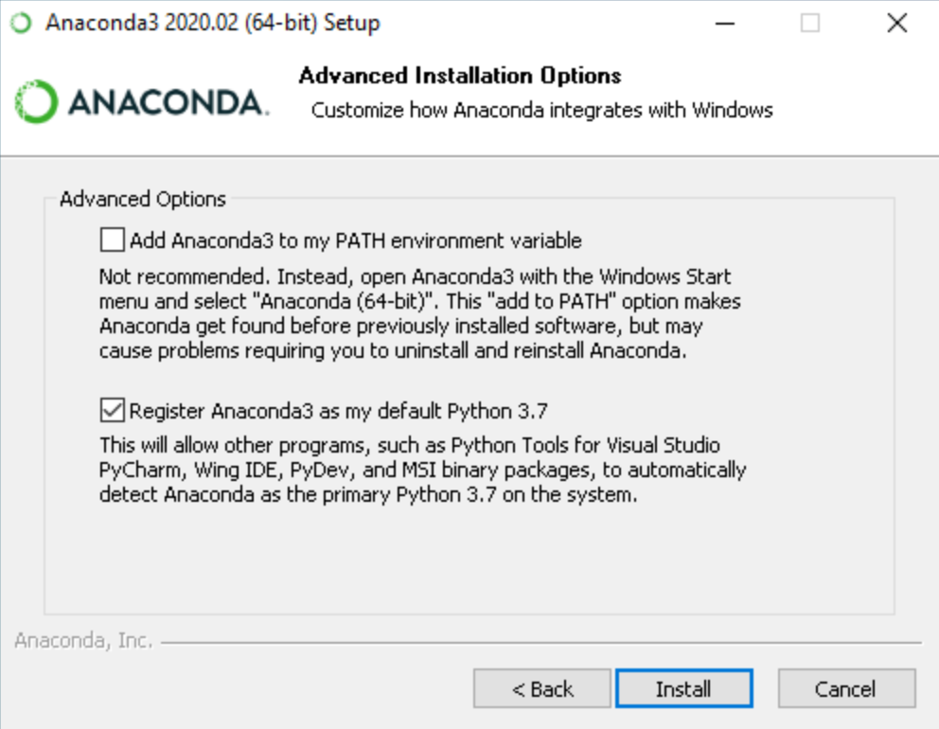](https://docs.anaconda.com/_images/win-install-options.png)

Figure-2: customizing installation interface

1. Choose whether to register Anaconda as your default Python. Unless you plan on installing and running multiple versions of Anaconda or multiple versions of Python, accept the default and leave this box checked.
2. Click the Install button. If want to watch the packages Anaconda is installing, click Show Details.
3. Click the Next button.
4. Optional: To install PyCharm for Anaconda, click on the link to <https://www.anaconda.com/pycharm>.

[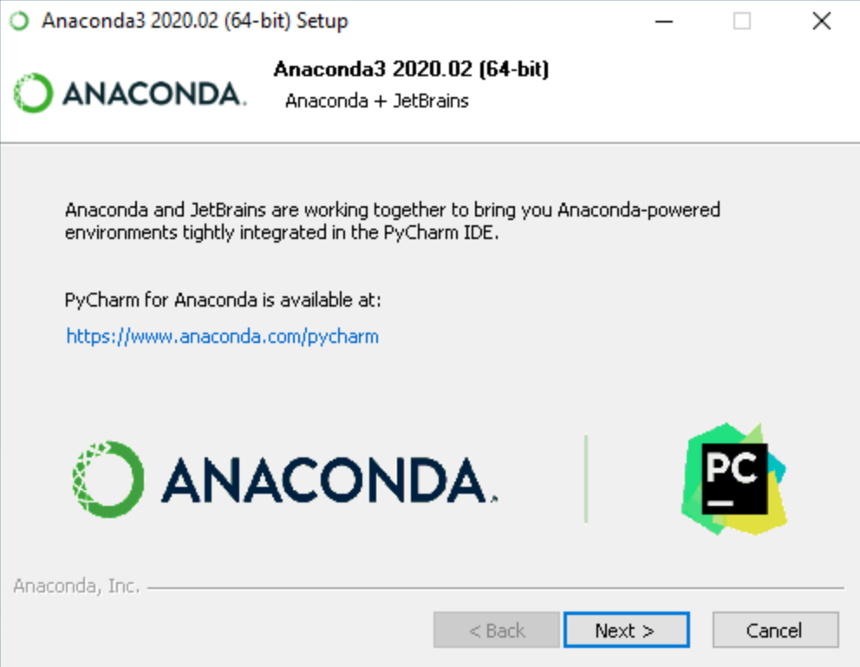](https://docs.anaconda.com/_images/win-install-pycharm.png)

Figure-3: Anaconda installation interface

1. Or to install Anaconda without PyCharm, click the Next button.
2. After a successful installation you will see the “Thanks for installing Anaconda” dialog box:

[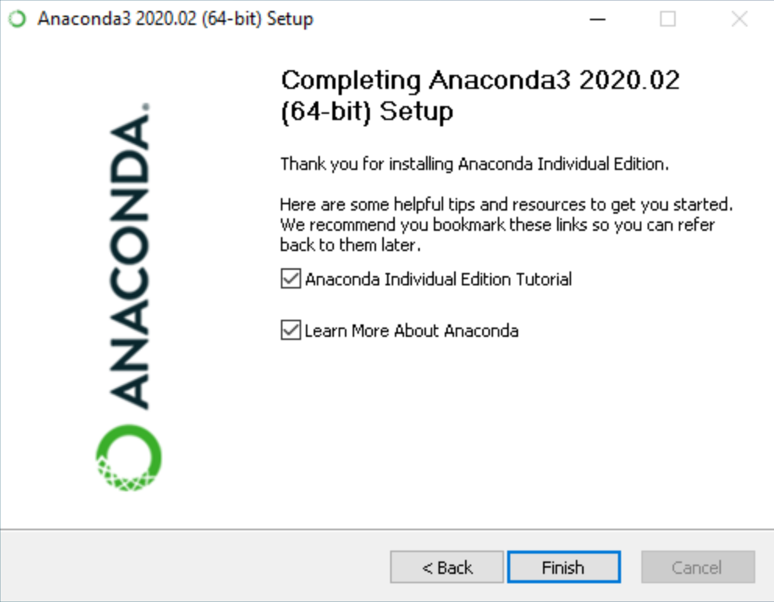](https://docs.anaconda.com/_images/win-install-complete.png)

Figure-4: Final installation interface

you wish to read more about Anaconda.org and how to get started with Anaconda, check the boxes “Anaconda Individual Edition Tutorial” and “Learn more about Anaconda”. Click the Finish button.

**Chapter -3**

**3.1 Writing First Code in Python**

3.1.1 Printing statement Codes: The following codes define how we can print statements in python.

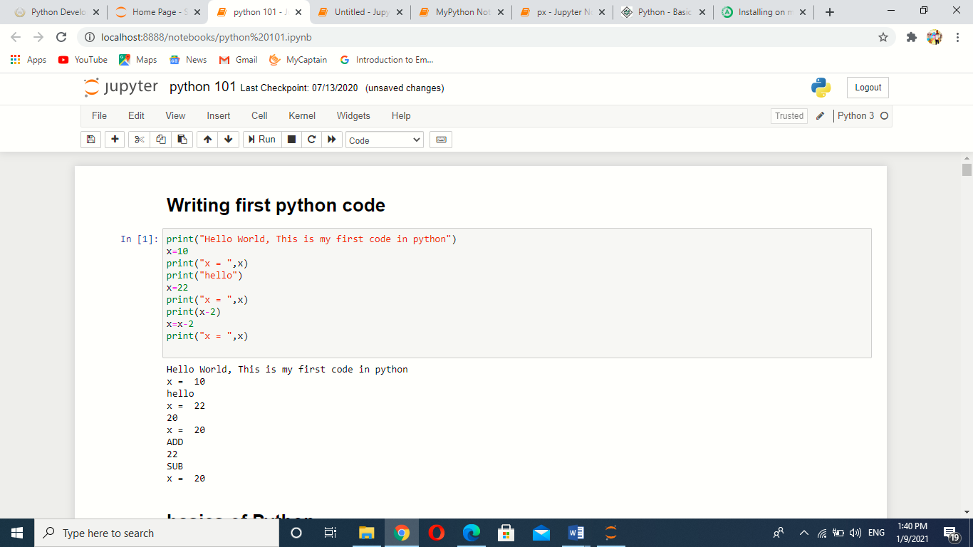

**3.2 Python Objects and Data Structures**

**3.2.1 Numbers-**Here are some direct commands to perform mathematical calculations on numbers

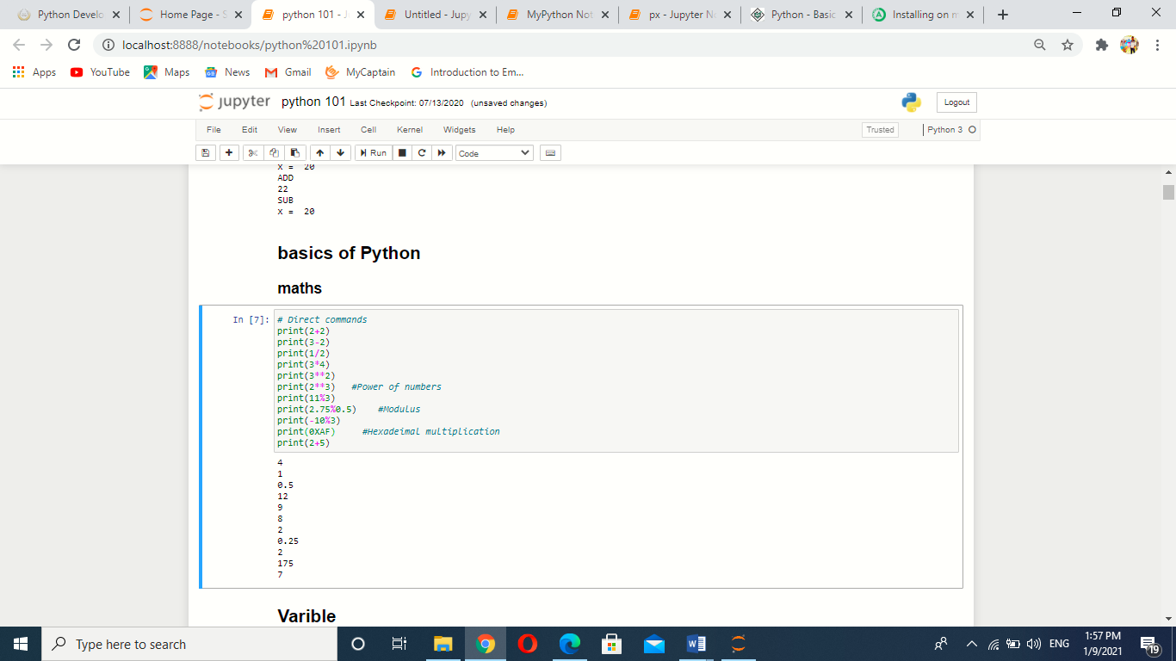

Python Supports many types of numbers as intergers(int), floating point numbers(float), complex numbers etc.

**3.2.2 Variables-**Variables are nothing but reserved memory locations to store values. This means that when you create a variable you reserve some space in memory.

Based on the data type of a variable, the interpreter allocates memory and decides what can be stored in the reserved memory. Therefore, by assigning different data types to variables, you can store integers, decimals or characters in these variables.

The declaration happens automatically when you assign a value to a variable. The equal sign (=) is used to assign values to variables.

The operand to the left of the = operator is the name of the variable and the operand to the right of the = operator is the value stored in the variable.

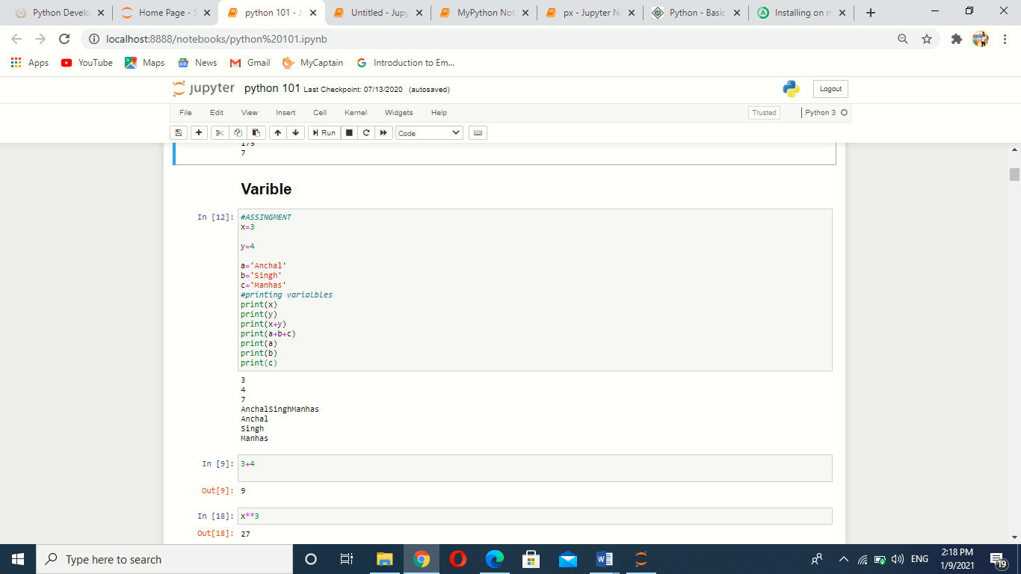

Strings are special case for assignment becase assignment of string is kept under quotes.

**3.2.3 List-** A list contains items separated by commas and enclosed within square brackets [ ].

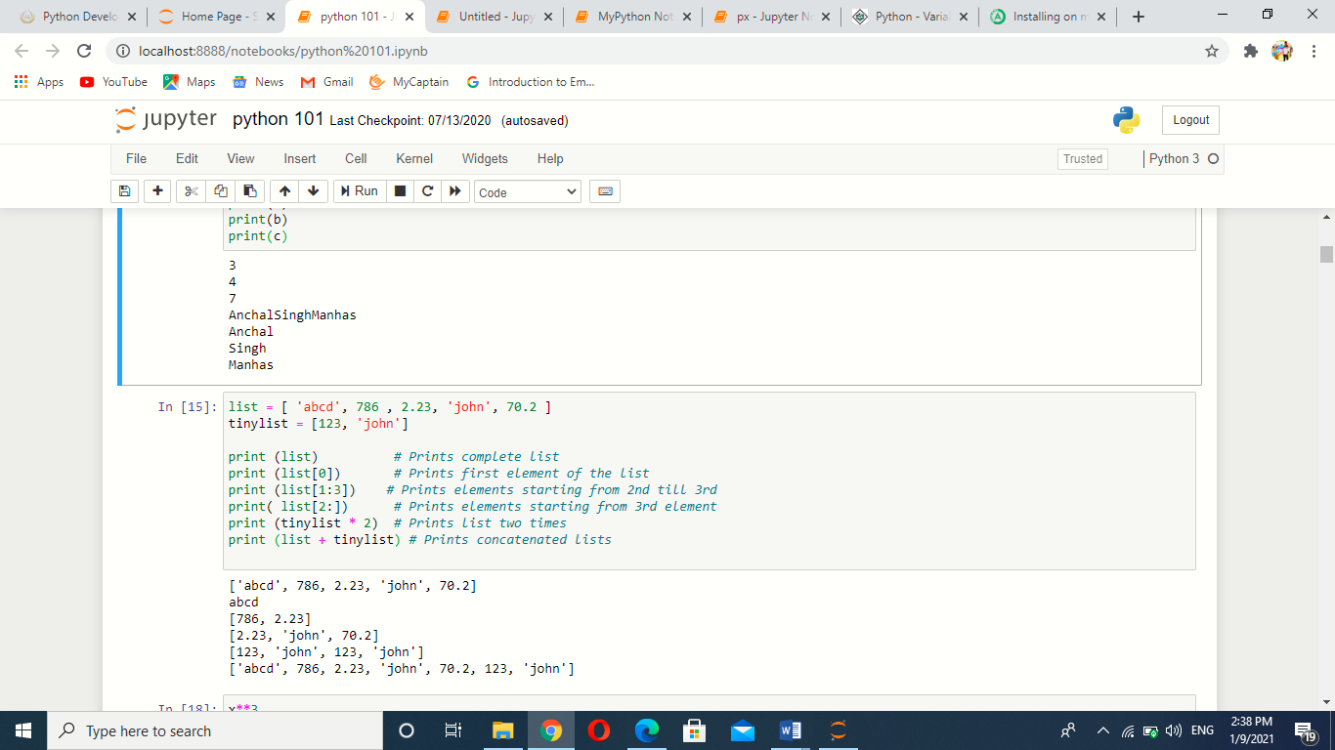

The values stored in a list can be accessed using the slice operator [ ] and [:] with indexes starting at 0 in the beginning of the list and working their way to end -1. The plus (+) sign is the list concatenation operator, and the asterisk (*) is the repetition operator.

**3.2.4 Tuples-** A tuple consists of a number of values separated by commas. Unlike lists, however, tuples are enclosed within parentheses.

The main differences between lists and tuples are: Lists are enclosed in brackets () and their elements and size can be changed, while tuples are enclosed in parentheses ( ) and cannot be updated. Tuples can be thought of as **read-only** lists.

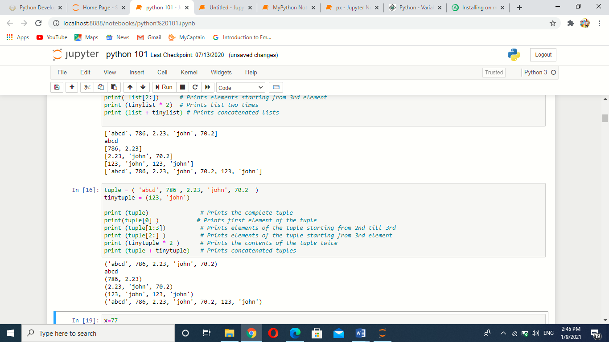

**3.2.5 Dictionaries-** Python's dictionaries are kind of hash table type. They work like associative arrays or hashes found in Perl and consist of key-value pairs.

A dictionary key can be almost any Python type, but are usually numbers or strings. Values, on the other hand, can be any arbitrary Python object.

Dictionaries are enclosed by curly braces ({ }) and values can be assigned and accessed using square braces [ ]

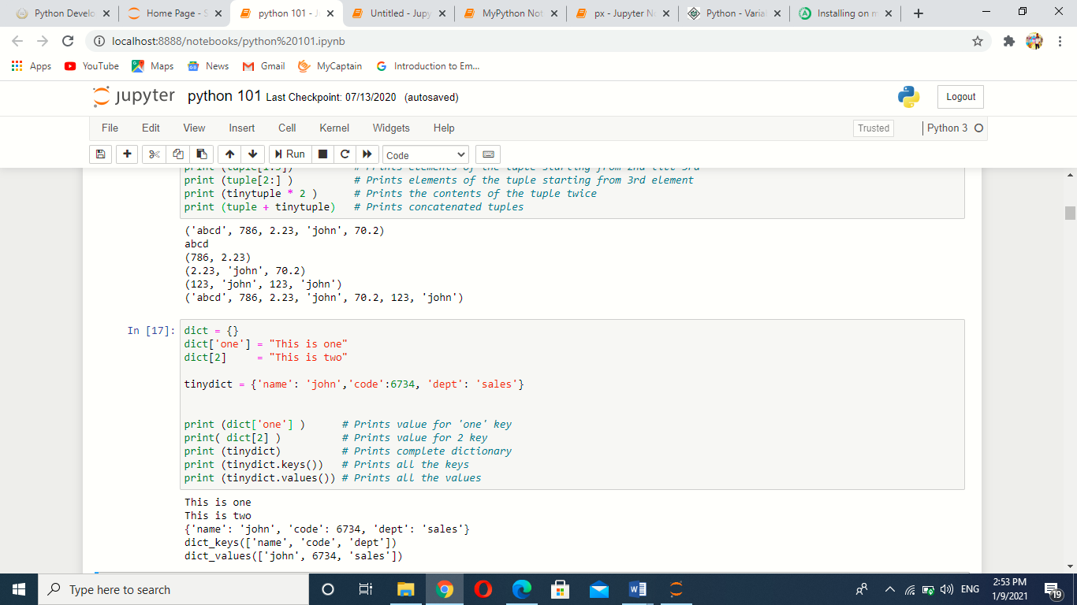

**3.2.6 Set-** set is another type of data which conatins elements enclosed in curly braces {} and it is mutable data type. i.e. elements can be updated in set.

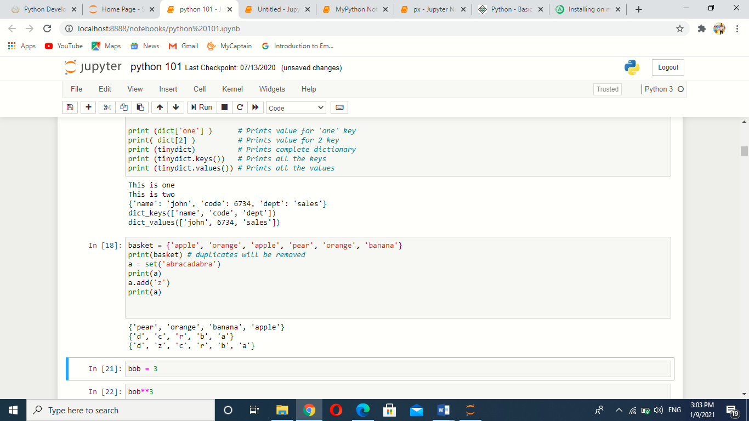

**3.3 Python operators**

Operators are the constructs which can manipulate the value of operands.

Consider the expression 4 + 5 = 9. Here, 4 and 5 are called operands and + is called operator.

**Types of Operator**

Python language supports the following types of operators.

* Arithmetic Operators
* Comparison (Relational) Operators
* Assignment Operators
* Logical Operators
* Bitwise Operators
* Membership Operators
* Identity Operators

**3.3.1 Arithmetic Operators**

|  |  |  |
| --- | --- | --- |
| Operator | Description | Example |
| + Addition | Adds values on either side of the operator. | a + b = 30 |
| - Subtraction | Subtracts right hand operand from left hand operand. | a – b = -10 |
| * Multiplication | Multiplies values on either side of the operator | a * b = 200 |
| / Division | Divides left hand operand by right hand operand | b / a = 2 |
| % Modulus | Divides left hand operand by right hand operand and returns remainder | b % a = 0 |
| ** Exponent | Performs exponential (power) calculation on operators | a**b =10 to the power 20 |
| // | Floor Division - The division of operands where the result is the quotient in which the digits after the decimal point are removed. But if one of the operands is negative, the result is floored, i.e., rounded away from zero (towards negative infinity) − | 9//2 = 4 and 9.0//2.0 = 4.0, -11//3 = -4, -11.0//3 = -4.0 |

**3.3.2 Comparision operators**

|  |  |  |
| --- | --- | --- |
| Operator | Description | Example |
| == | If the values of two operands are equal, then the condition becomes true. | (a == b) is not true. |
| != | If values of two operands are not equal, then condition becomes true. | (a != b) is true. |
| <> | If values of two operands are not equal, then condition becomes true. | (a <> b) is true. This is similar to != operator. |
| > | If the value of left operand is greater than the value of right operand, then condition becomes true. | (a > b) is not true. |
| < | If the value of left operand is less than the value of right operand, then condition becomes true. | (a < b) is true. |
| >= | If the value of left operand is greater than or equal to the value of right operand, then condition becomes true. | (a >= b) is not true. |
| <= | If the value of left operand is less than or equal to the value of right operand, then condition becomes true. | (a <= b) is true. |

**3.3.3 Assignment Operators**

|  |  |  |
| --- | --- | --- |
| **Operator** | **Description** | **Example** |
| = | Assigns values from right side operands to left side operand | c = a + b assigns value of a + b into c |
| += Add AND | It adds right operand to the left operand and assign the result to left operand | c += a is equivalent to c = c + a |
| -= Subtract AND | It subtracts right operand from the left operand and assign the result to left operand | c -= a is equivalent to c = c - a |
| *= Multiply AND | It multiplies right operand with the left operand and assign the result to left operand | c *= a is equivalent to c = c * a |
| /= Divide AND | It divides left operand with the right operand and assign the result to left operand | c /= a is equivalent to c = c / a |
| %= Modulus AND | It takes modulus using two operands and assign the result to left operand | c %= a is equivalent to c = c % a |
| **= Exponent AND | Performs exponential (power) calculation on operators and assign value to the left operand | c **= a is equivalent to c = c ** a |
| //= Floor Division | It performs floor division on operators and assign value to the left operand | c //= a is equivalent to c = c // a |

**3.3.4 Bitwise Operators**

Bitwise operator works on bits and performs bit by bit operation. Assume if a = 60; and b = 13; in the binary format their values will be 0011 1100 and 0000 1101.

|  |  |  |
| --- | --- | --- |
| **Operator** | **Description** | **Example** |
| & Binary AND | Operator copies a bit to the result if it exists in both operands | (a & b) (means 0000 1100) |
| | Binary OR | It copies a bit if it exists in either operand. | (a | b) = 61 (means 0011 1101) |
| ^ Binary XOR | It copies the bit if it is set in one operand but not both. | (a ^ b) = 49 (means 0011 0001) |
| ~ Binary Ones Complement | It is unary and has the effect of 'flipping' bits. | (~a ) = -61 (means 1100 0011 in 2's complement form due to a signed binary number. |
| << Binary Left Shift | The left operands value is moved left by the number of bits specified by the right operand. | a << 2 = 240 (means 1111 0000) |
| >> Binary Right Shift | The left operands value is moved right by the number of bits specified by the right operand. | a >> 2 = 15 (means 0000 1111) |

**3.3.5 Logical Operators-**

|  |  |  |
| --- | --- | --- |
| **Operator** | **Description** | **Example** |
| and Logical AND | If both the operands are true then condition becomes true. | (a and b) is true. |
| or Logical OR | If any of the two operands are non-zero then condition becomes true. | (a or b) is true. |
| not Logical NOT | Used to reverse the logical state of its operand. | Not(a and b) is false. |

**3.4 Python Operators precedence:** The following table shows the precedence from highest to lowest.

|  |  |
| --- | --- |
| Sr.No | Operator & Description |
| 1 | **  Exponentiation (raise to the power) |
| 2 | ~ + -  Complement, unary plus and minus (method names for the last two are +@ and -@) |
| 3 | * / % //  Multiply, divide, modulo and floor division |
| 4 | + -  Addition and subtraction |
| 5 | >> <<  Right and left bitwise shift |
| 6 | &  Bitwise 'AND' |
| 7 | ^ |  Bitwise exclusive `OR' and regular `OR' |
| 8 | <= < > >=  Comparison operators |
| 9 | <> == !=  Equality operators |
| 10 | = %= /= //= -= += *= **=  Assignment operators |
| 11 | is is not  Identity operators |
| 12 | in not in  Membership operators |

Chapter-4

**4.1 Python Decision Statement**

Decision making is anticipation of conditions occurring while execution of the program and specifying actions taken according to the conditions.

Decision structures evaluate multiple expressions which produce TRUE or FALSE as outcome. It determine which action to take and which statements to execute if outcome is TRUE or FALSE otherwise.

Following is the general form of a typical decision making structure found in most of the programming languages −

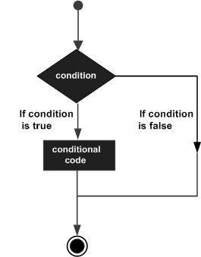

Figure-5:Conditional decision flow diagram

Python programming language assumes any **non-zero** and **non-null** values as TRUE, and if it is either **zero** or **null**, then it is assumed as FALSE value.

Python has four decision making statements:

* If statement
* If else statement
* Elif statement
* Nested if statement

**4.1.1 If statement:** The **if** statement contains a logical expression using which data is compared and a decision is made based on the result of the comparison.

Syntax

If expression:

statement(s)

Flow diagram:

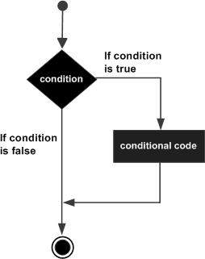

Figure-6: if condition

Example:

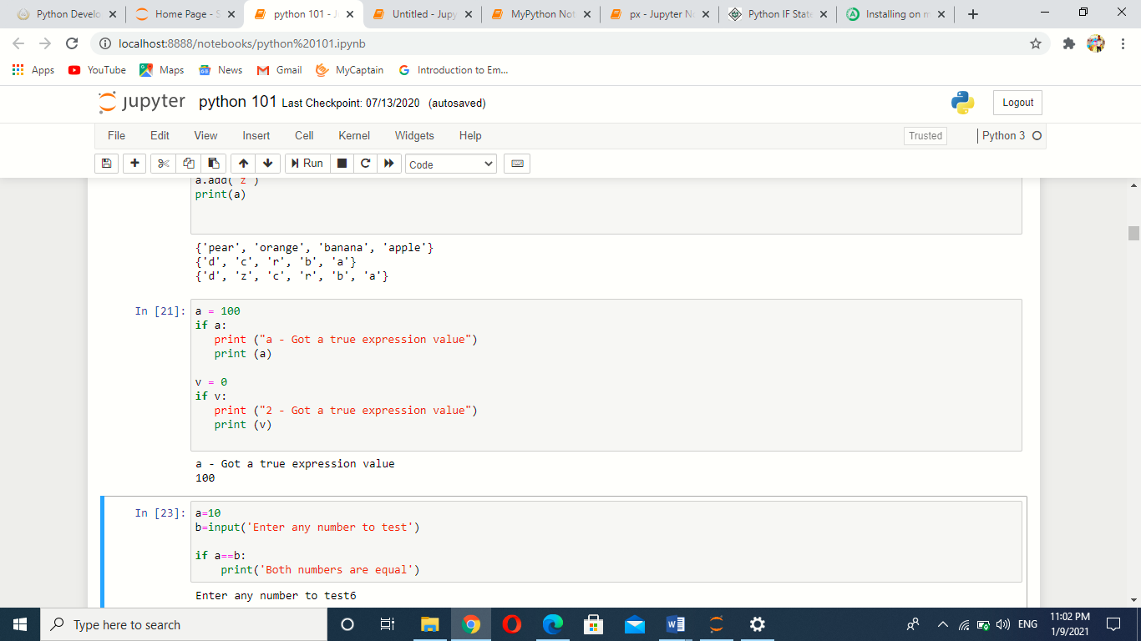

**4.1.2 Else-if statement:**  An **else** statement contains the block of code that executes if the conditional expression in the if statement resolves to 0 or a FALSE value.

The *else* statement is an optional statement and there could be at most only one **else** statement following **if**.

Syntax:

If expression:

Statement (s)

Else expression:

Statement (s)

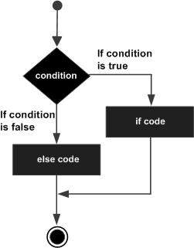

Figure-7:if else condition

Example

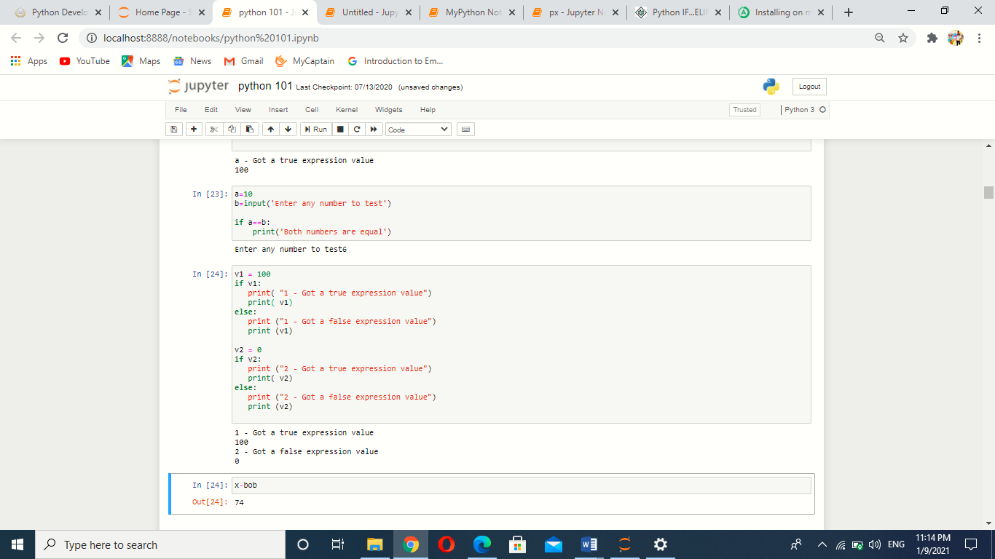

**4.1.3 Elif statement:** The **elif** statement allows you to check multiple expressions for TRUE and execute a block of code as soon as one of the conditions evaluates to TRUE.

Syntax:

if expression1:

statement (s)

elif expression2:

statement (s)

elif expression3:

statement (s)

else:

statement (s)

Example

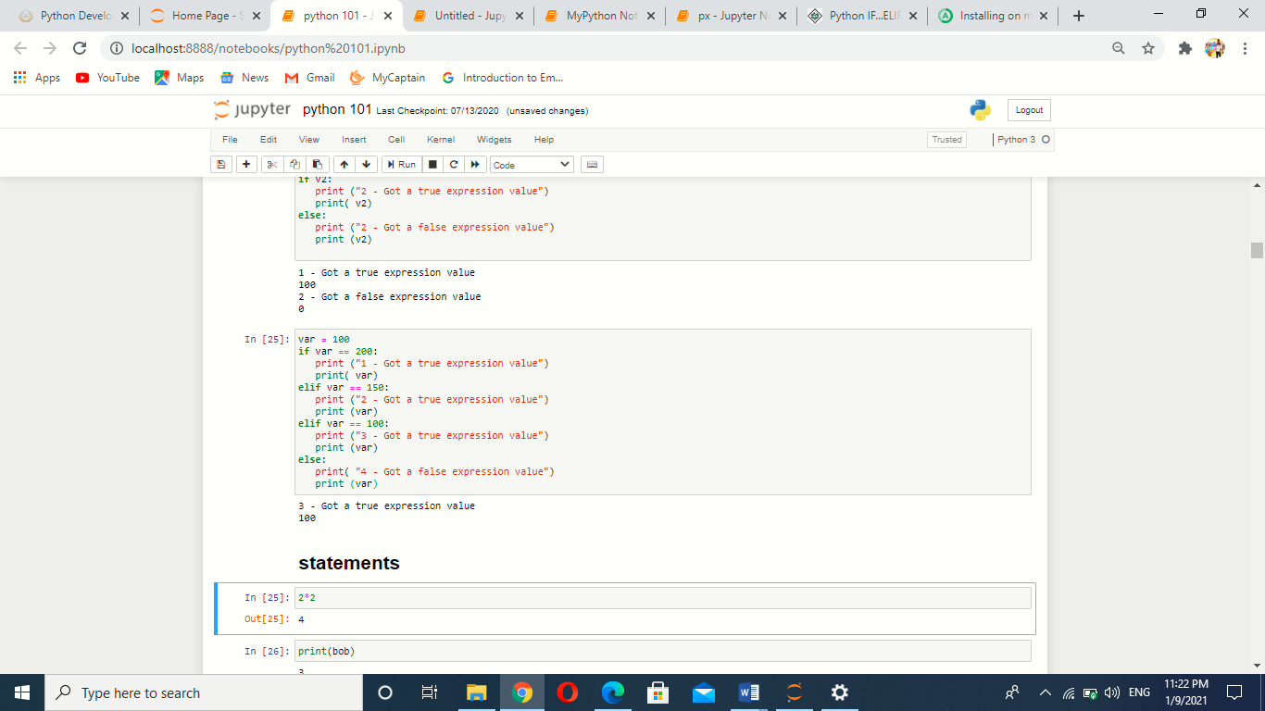

**4.1.4 Nested if statement:** There may be a situation when you want to check for another condition after a condition resolves to true. In such a situation, we can use the nested **if** construct.

In a nested **if** construct, we havean **if...elif...else** construct inside another **if...elif...else** construct.

Syntax

if expression1:

statement(s)

if expression2:

statement(s)

elif expression3:

statement(s)

elif expression4:

statement(s)

else:

statement(s)

else:

statement(s)

Example:

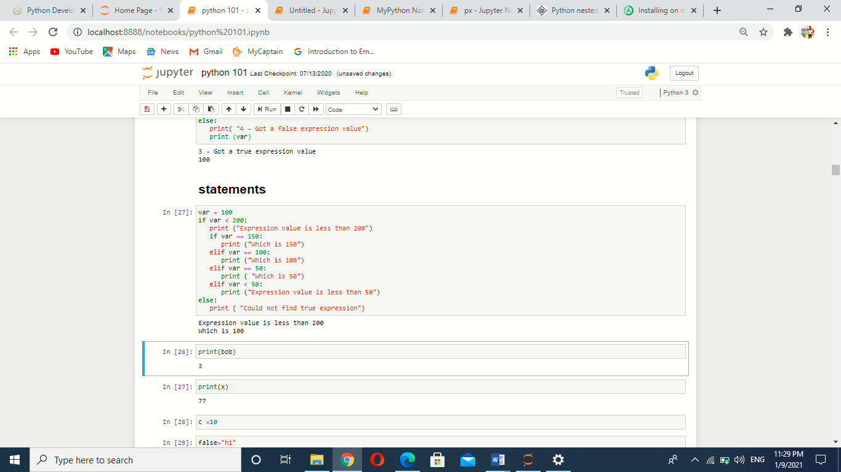

**Chapter-5**

**5.1 Loops in Python**

Programming languages provide various control structures that allow for more complicated execution paths.

A loop statement allows us to execute a statement or group of statements multiple times. The following diagram illustrates a loop statement −

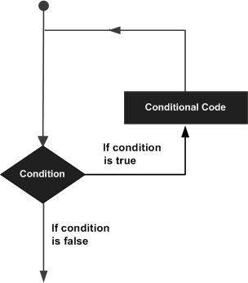

Figure-8: Conditional Looping diagram

There are few loop statements available as:

* While loop
* For loop
* Nested loops

**5.1.1 While loop:** A while loop statement in Python programming language repeatedly executes a target statement as long as a given condition is true.

Syntax:

while expression:

statement(s)

 statement(s) may be a single statement or a block of statements. The condition may be any expression, and true is any non-zero value. The loop iterates while the condition is true.

When the condition becomes false, program control passes to the line immediately following the loop.

In Python, all the statements indented by the same number of character spaces after a programming construct are considered to be part of a single block of code. Python uses indentation as its method of grouping statements.

Flow diagram:

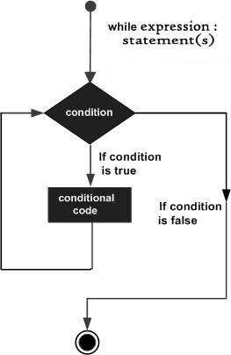

Figure-9: while Conditional loop

Example:

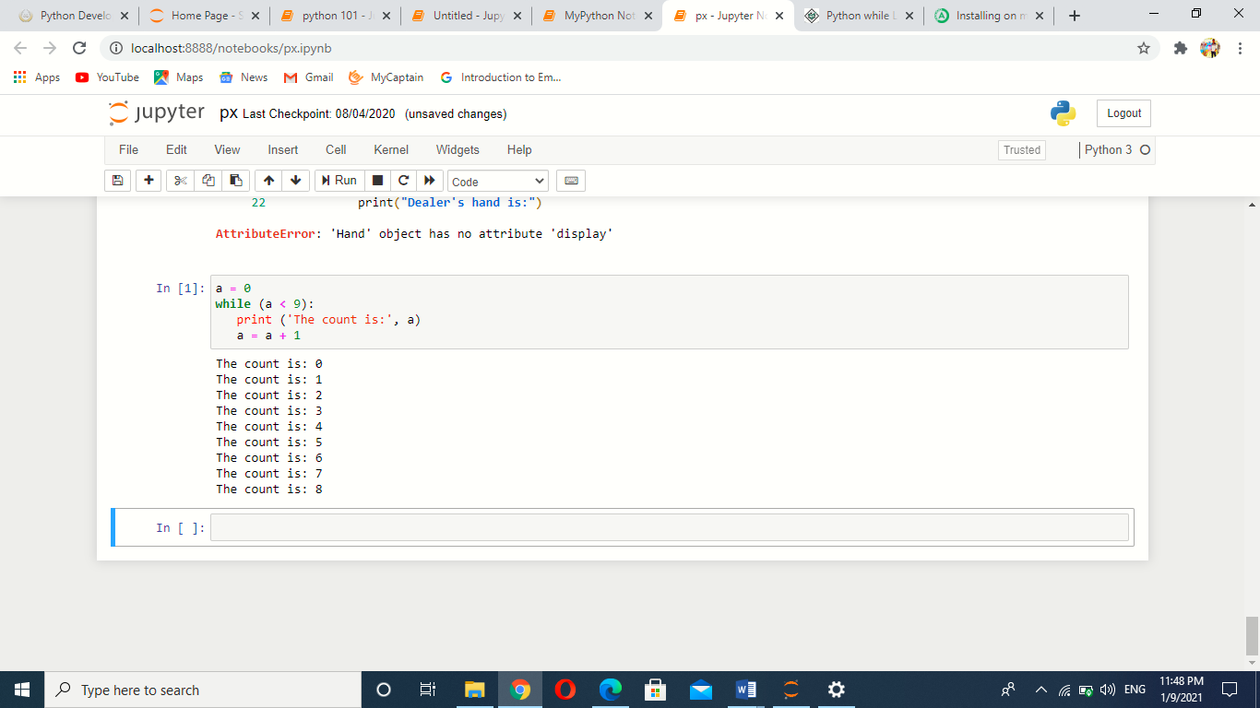

**5.1.2 For loop:** It has the ability to iterate over the items of any sequence, such as a list or a string.

Syntax:

for iterating_var in sequence:

statements(s)

If a sequence contains an expression list, it is evaluated first. Then, the first item in the sequence is assigned to the iterating variable *iterating_var*. Next, the statements block is executed. Each item in the list is assigned to *iterating_var*, and the statement(s) block is executed until the entire sequence is exhausted.

Flow chart

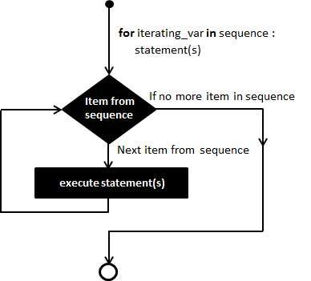

Figure-10: For looping

Example

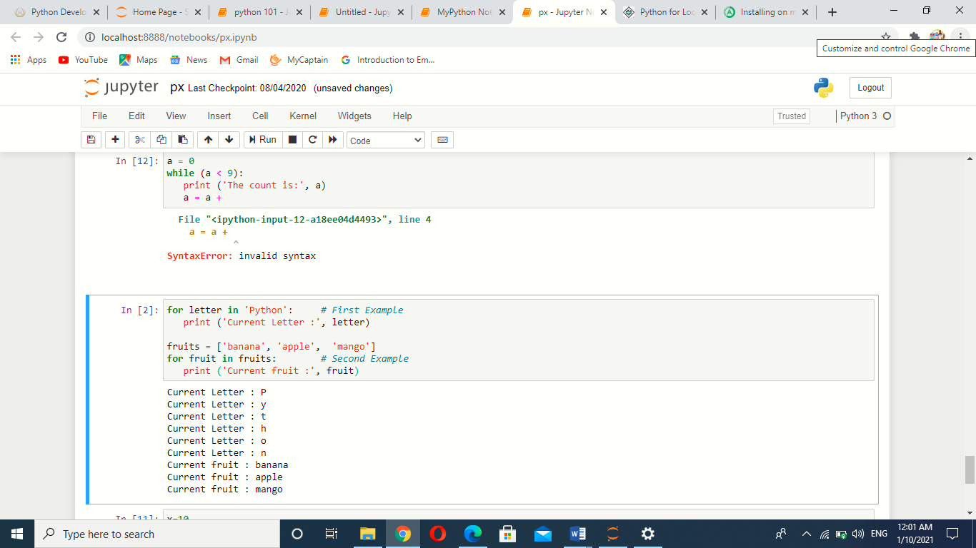

**5.1.3 Nested loops:** Python programming language allows to use one loop inside another loop.

Syntax

for iterating_var in sequence:

for iterating_var in sequence:

statements(s)

statements(s)

Example:

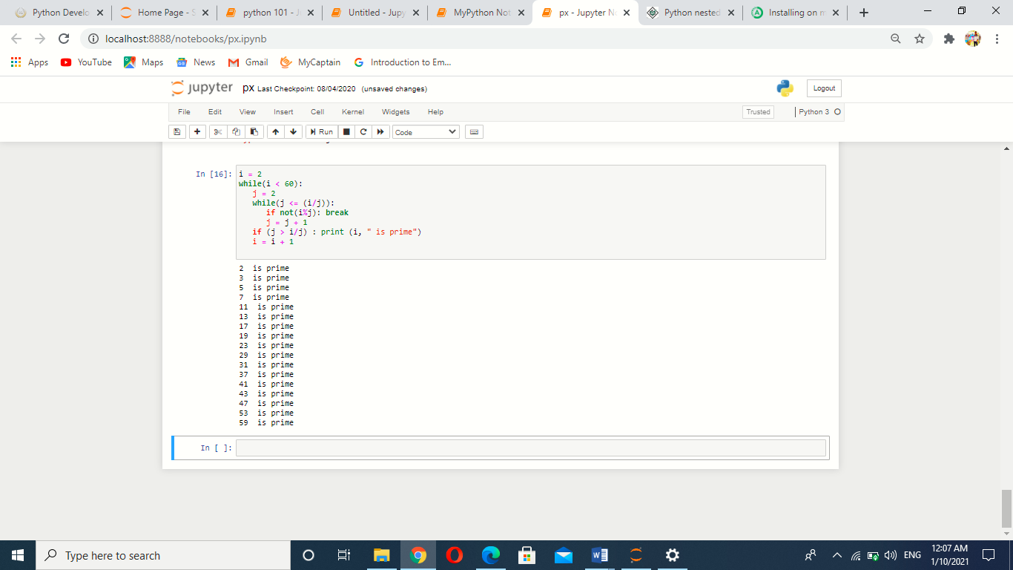

**Chapter-6**

**6.1 Control statements**

Loop control statements change execution from its normal sequence. When execution leaves a scope, all automatic objects that were created in that scope are destroyed.

Python supports the following control statements

* Break statement
* Continue Statement
* Pass statement

**6.1.1 Break Statement:** It terminates the current loop and resumes execution at the next statement.

The most common use for break is when some external condition is triggered requiring a hasty exit from a loop. The **break** statement can be used in both *while* and *for* loops.

If we are using nested loops, the break statement stops the execution of the innermost loop and start executing the next line of code after the block.

Flow chart:

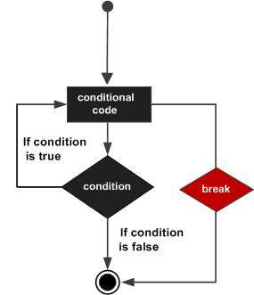

Figure-11: Break statement

Example:

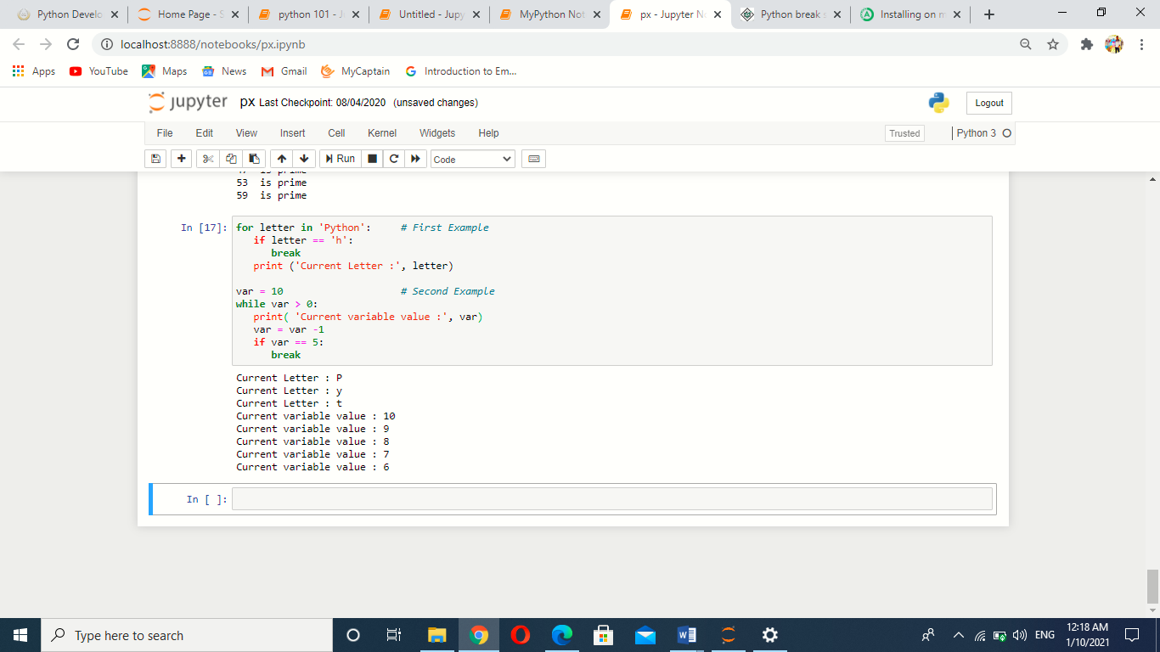

**6.1.2 Continue Statement:** It returns the control to the beginning of the while loop. The **continue** statement rejects all the remaining statements in the current iteration of the loop and moves the control back to the top of the loop.

The **continue** statement can be used in both *while* and *for* loops.

Flow Chart:

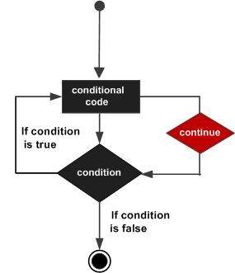

Figure-12: Continue Statement

Example:

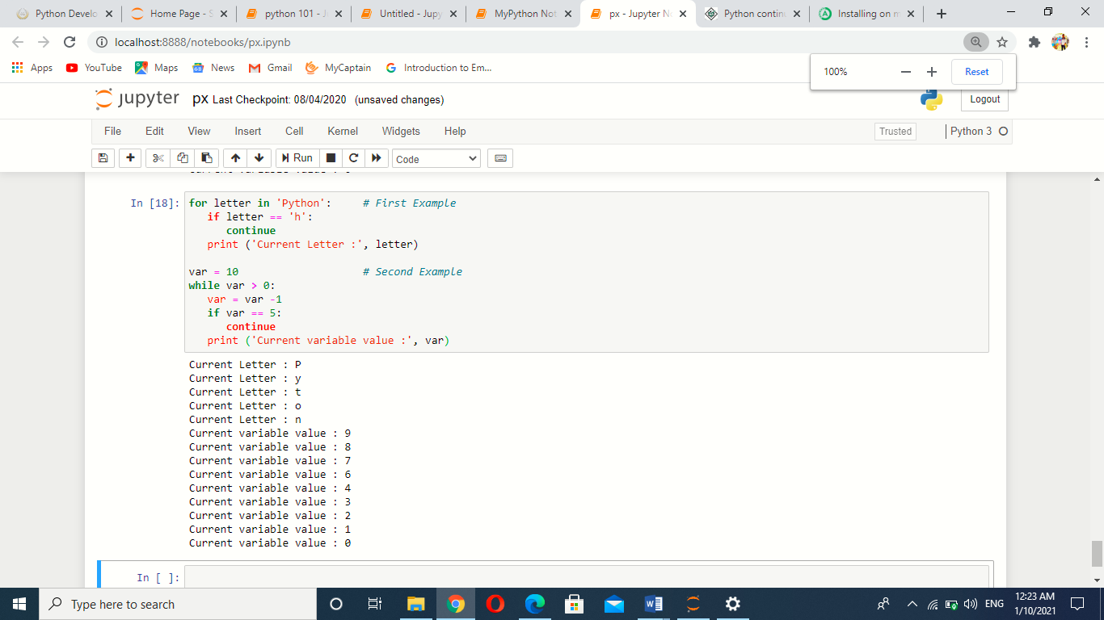

**6.1.3 Pass statement:** It is used when a statement is required syntactically but we do not want any command or code to execute.

The pass statement is a *null* operation; nothing happens when it executes. The pass is also useful in places where code will eventually go, but has not been written yet.

Example:

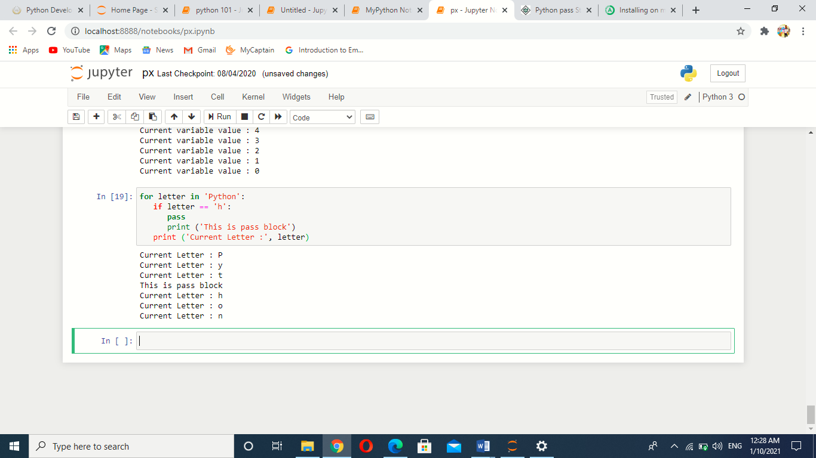

**Chapter-7**

**7.1 Functions in python**

A function is a block of organized, reusable code that is used to perform a single, related action. Functions provide better modularity for your application and a high degree of code reusing.

Python gives us many built-in functions like print(), etc. but we can also create our own functions. These functions are called *user-defined functions.*

**7.1.1 Defining a Function**

We can define functions to provide the required functionality. Here are simple rules to define a function in Python.

* Function blocks begin with the keyword def followed by the function name and parentheses ()
* Any input parameters or arguments should be placed within these parentheses. We can also define parameters inside these parentheses.
* The first statement of a function can be an optional statement - the documentation string of the function or *docstring*.
* The code block within every function starts with a colon (:) and is indented.
* The statement return [expression] exits a function, optionally passing back an expression to the caller. A return statement with no arguments is the same as return None.

Syntax

def functionname( parameters ):

"function_docstring"

function_suite

return [expression]

e.g

def printme( str ):

"This prints a passed string into this function"

print str

return

**7.1.2 Calling a Function**

Defining a function only gives it a name, specifies the parameters that are to be included in the function and structures the blocks of code.

Once the basic structure of a function is finalized, we can execute it by calling it from another function or directly from the Python prompt.

Example:

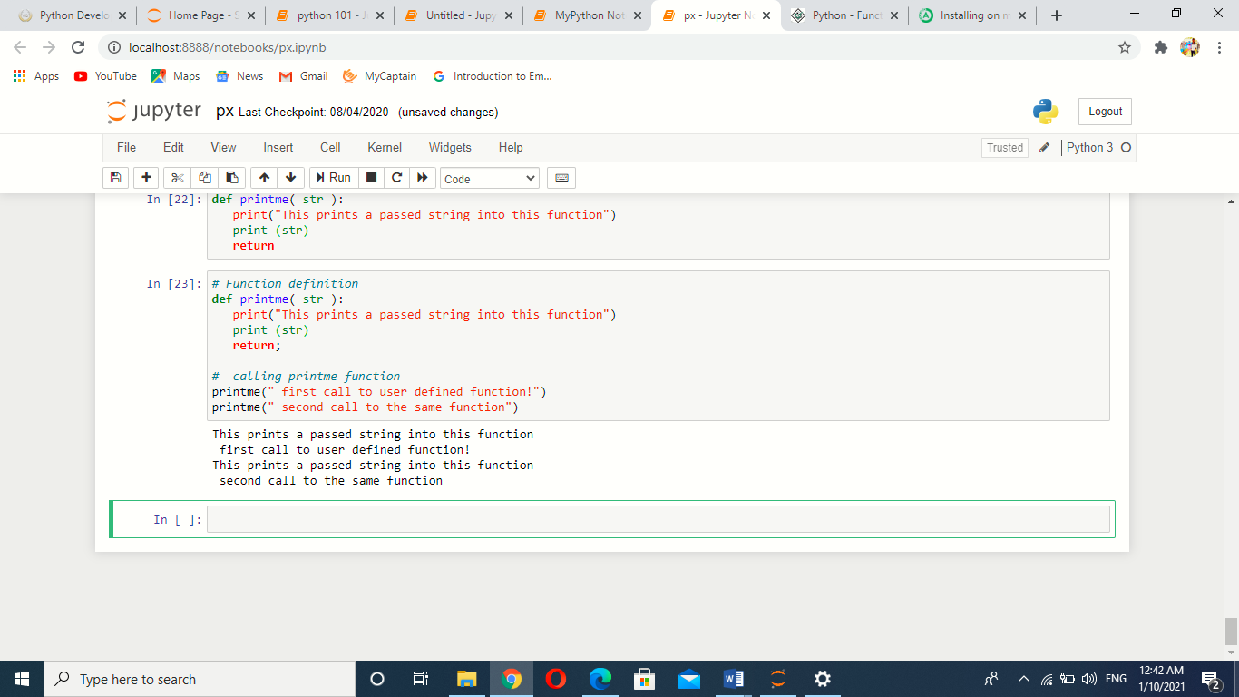

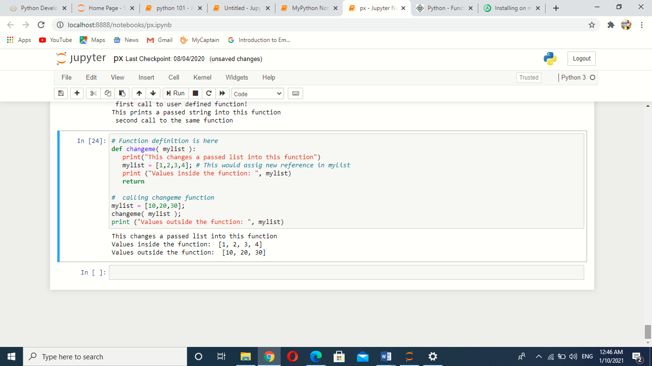

**7.2 Global vs. Local variables:**

Variables that are defined inside a function body have a local scope, and those defined outside have a global scope.

This means that local variables can be accessed only inside the function in which they are declared, whereas global variables can be accessed throughout the program body by all functions. When we call a function, the variables declared inside it are brought into scope

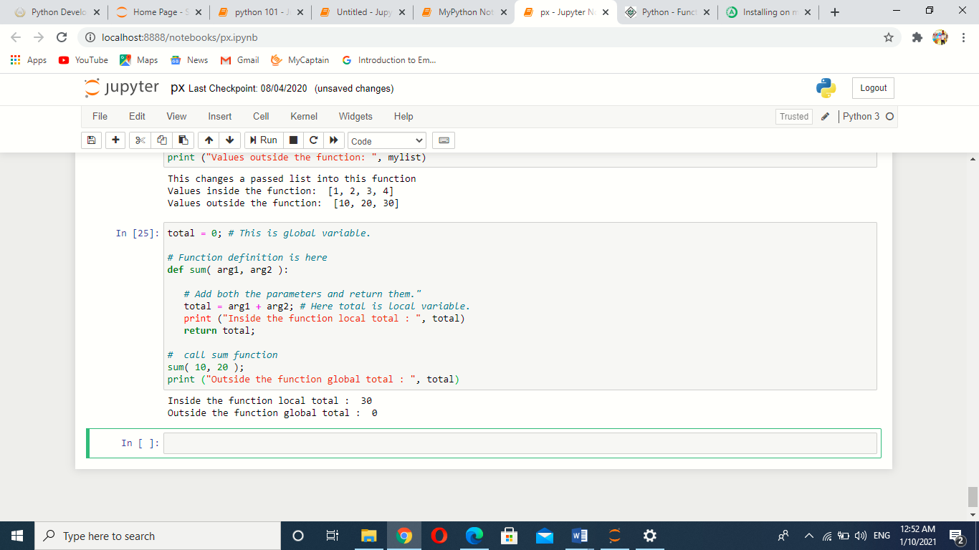

**7.3 Pass by reference vs value:**

All parameters (arguments) in the Python language are passed by reference. It means if we change what a parameter refers to within a function, the change also reflects back in the calling function. For example −

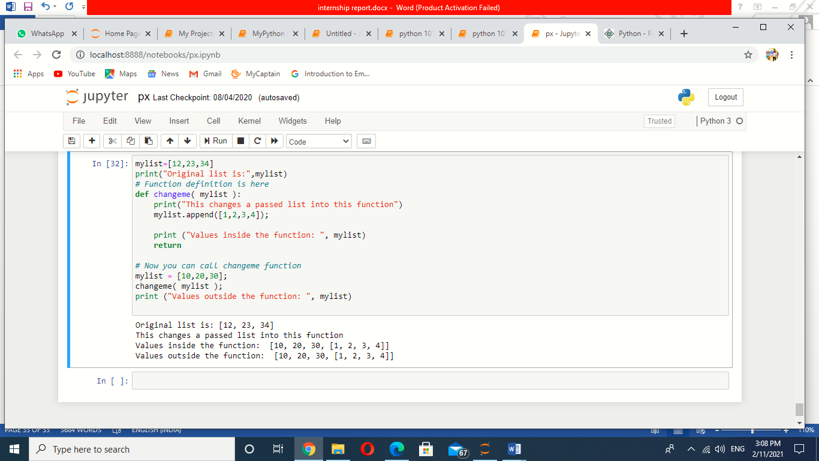

There is one more example where argument is being passed by reference and the reference is being overwritten inside the called function.

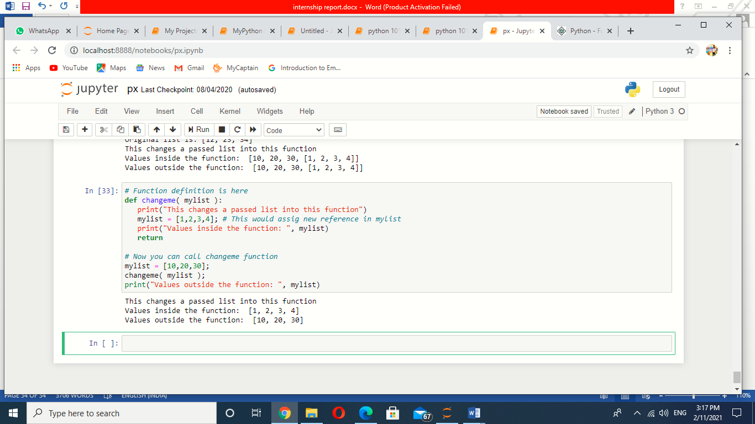

The parameter *mylist* is local to the function changeme. Changing mylist within the function does not affect *mylist*. The function accomplishes nothing and finally this would produce the result

**7.4 Function Arguments**

You can call a function by using the following types of formal arguments −

* Required arguments
* Keyword arguments
* Default arguments

**7.4.1 Required arguments**

Required arguments are the arguments passed to a function in correct positional order. Here, the number of arguments in the function call should match exactly with the function definition.

To call the function *printme()*, you definitely need to pass one argument, otherwise it gives a syntax error as follows −

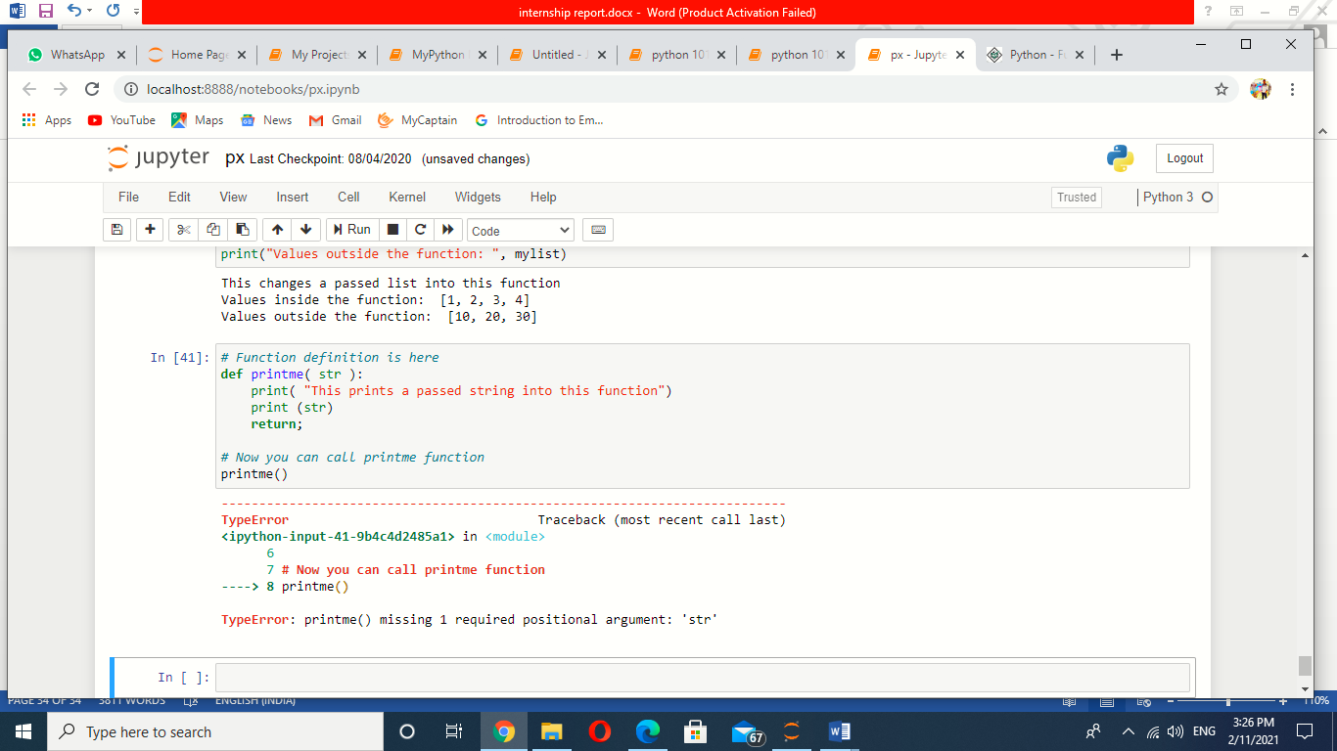

**7.4.2 Keyword arguments**

Keyword arguments are related to the function calls. When we use keyword arguments in a function call, the caller identifies the arguments by the parameter name.

This allows us to skip arguments or place them out of order because the Python interpreter is able to use the keywords provided to match the values with parameters.We can also make keyword calls to the *printme()* function in the following ways −

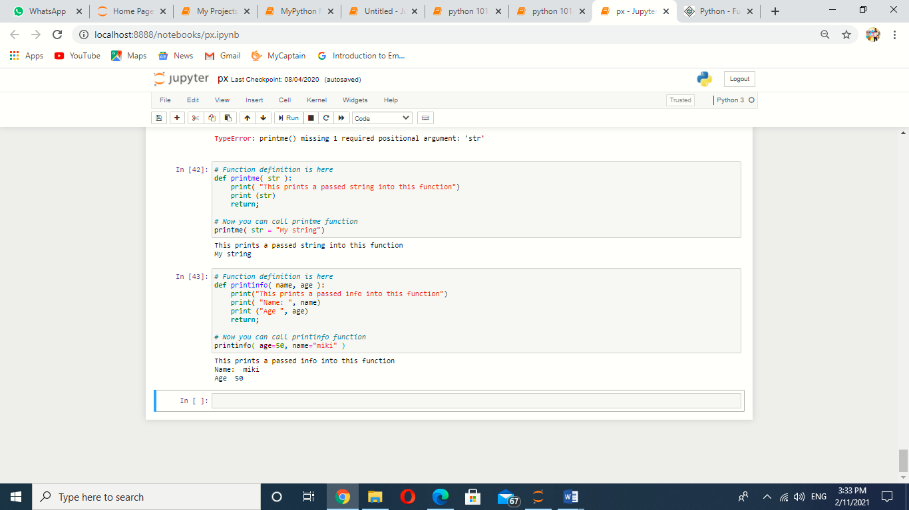

**7.4.3 Default arguments**

A default argument is an argument that assumes a default value if a value is not provided in the function call for that argument. The following example gives an idea on default arguments, it prints default age if it is not passed

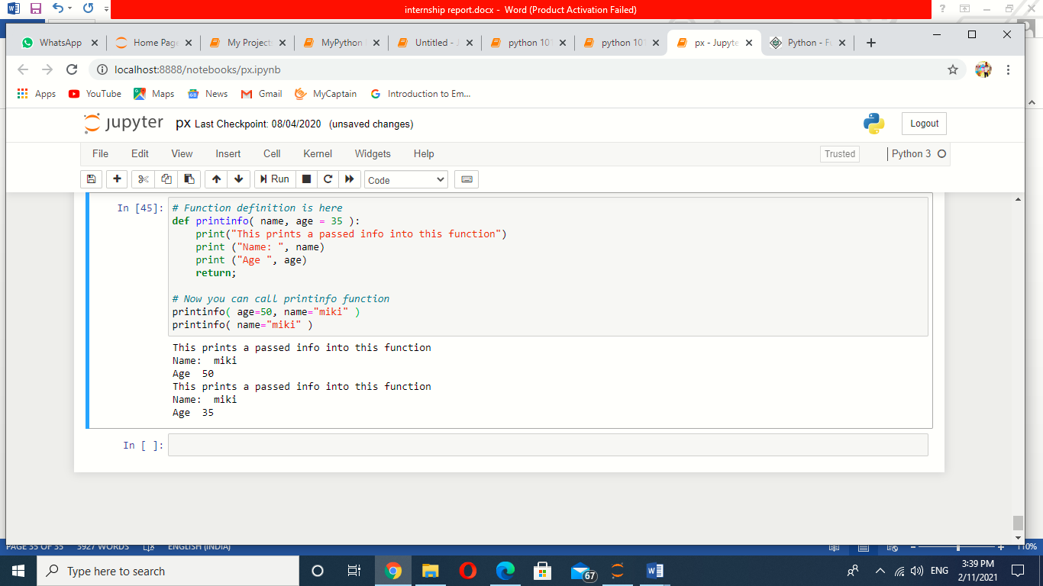

**7.5 Lambda Functions:** These are small functions which are not defined with any name and carry a single expression whose result is returned. Lambda functions comes very handy when operating with lists. These function are defined by the keyword **lambda** followed by the variables, a colon and the respective expression.

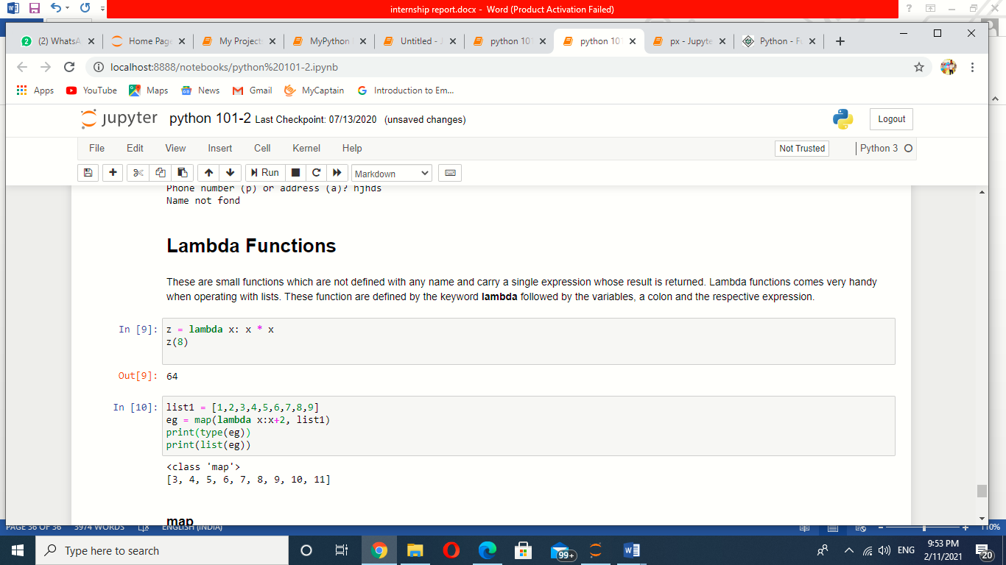

**map( )** function basically executes the function that is defined to each of the list's element separately.

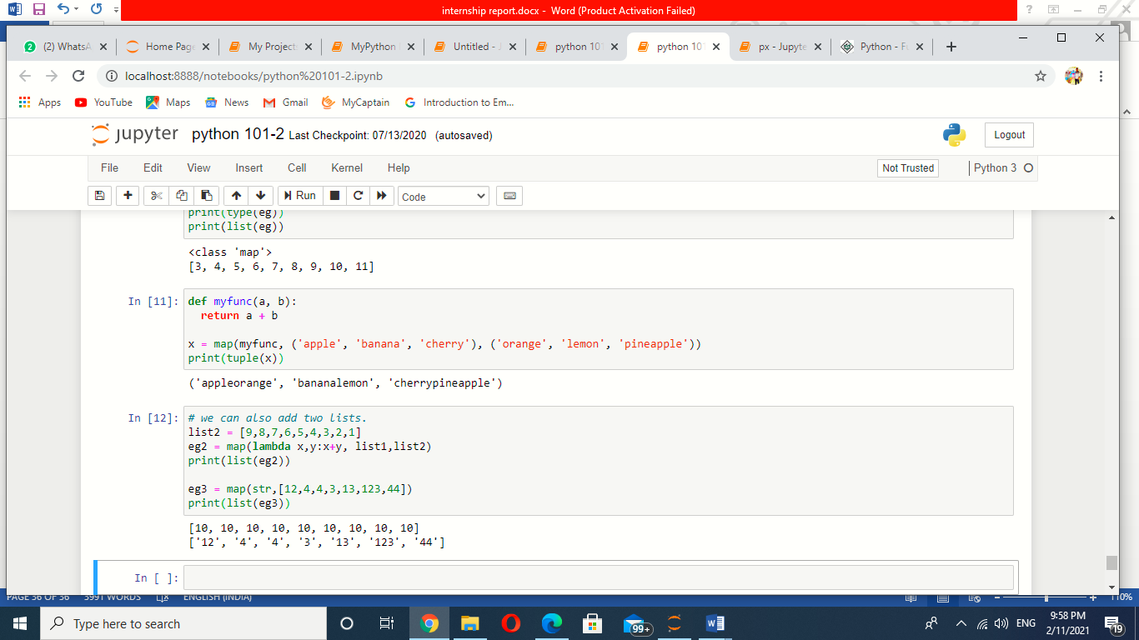

**filter( )** function is used to filter out the values in a list. Note that **filter()** function returns the result in a new list.

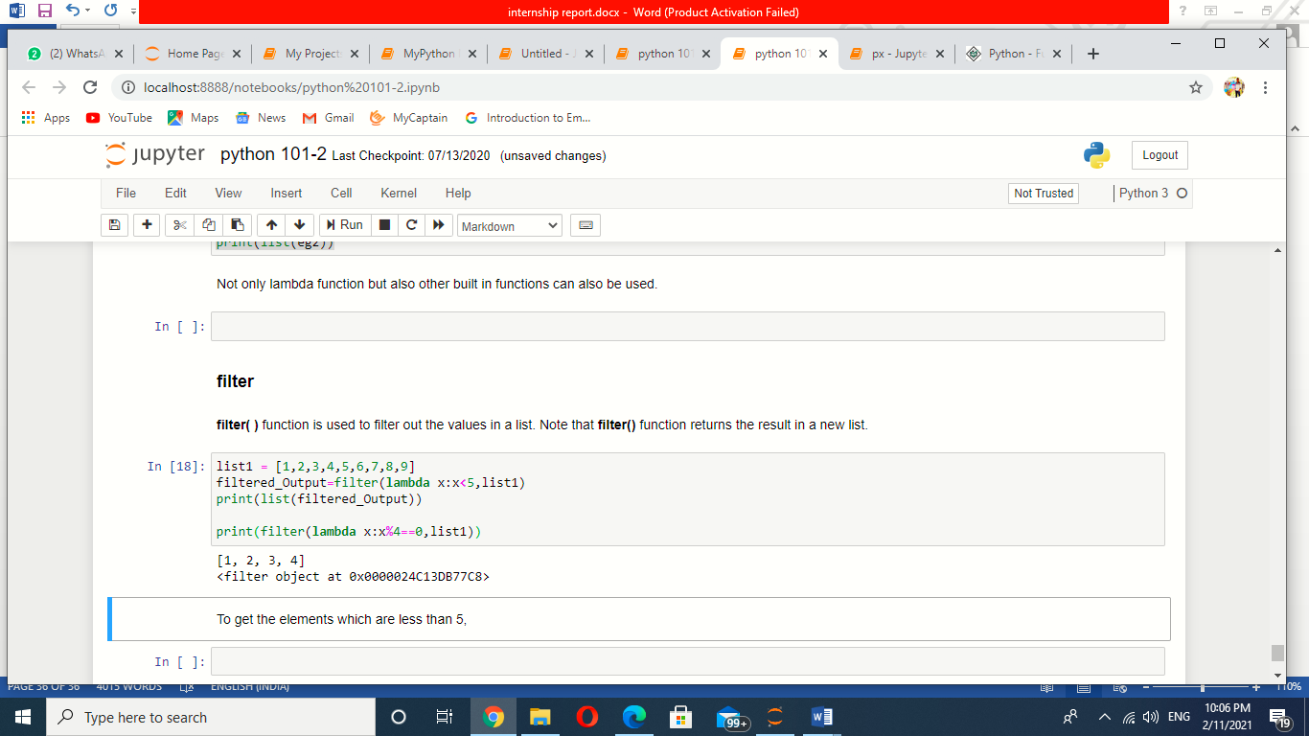

**Chapter-8**

**8.1 Object oriented programming:**

The term “Object-Oriented Programming” (OOP) was coined by Alan Kay around 1966

Object-Oriented Programming (OOP), is all about creating “objects”. An object is a group of interrelated variables and functions. These variables are often referred to as properties of the object and functions are referred to as the behaviour of the objects. These objects provide a better and clear structure for the program.

For example, a car can be an object. If we consider the car as an object then its properties would be – its colour, its model, its price, its brand, etc. And its behaviour function would be acceleration, slowing down, gear change.

Another example-If we consider a dog as an object then its properties would be- his colour, his breed, his name, his weight, etc. And his behaviour/function would be walking, barking, playing, etc.

**8.2 What is Class?**

Class is a collection of objects. Unlike the primitive data structures, classes are data structures that the user defines.

Syntax:

Class class name:

Class body

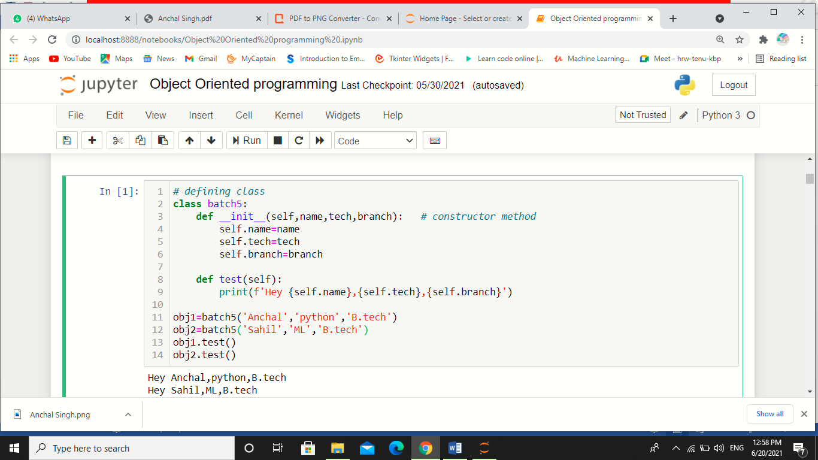

**8.3 Inheritance**

Inheritance Means “inheriting or transfer of characteristics from parent to child class without any modification”. The new class is called the derived/child class and the one from which it is derived is called a parent/base class.

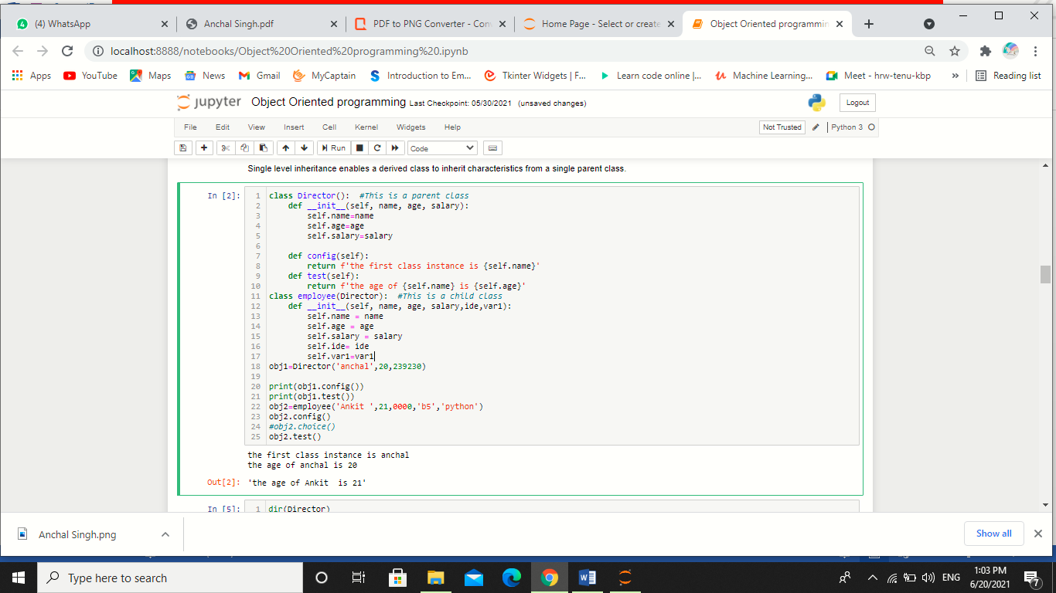

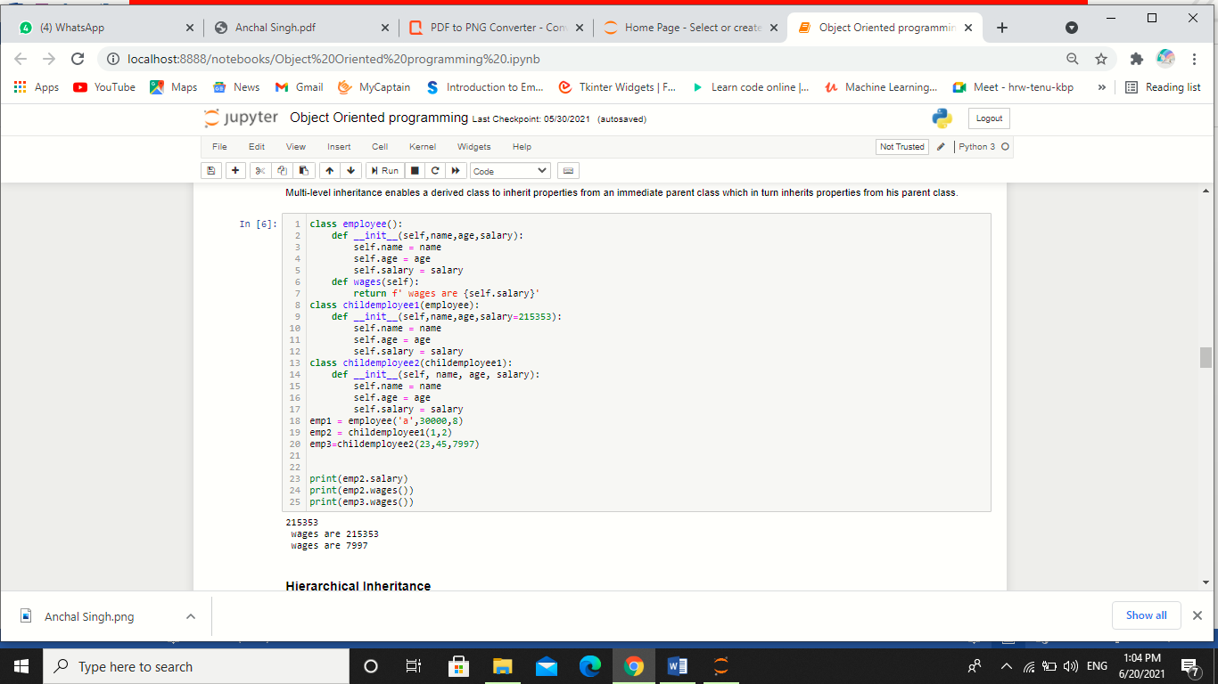

**8.4 Polymorphism**

While functions can take in different arguments, methods belong to the objects they act on. In Python, polymorphism refers to the way in which different object classes can share the same method name, and those methods can be called from the same place even though a variety of different objects might be passed in.

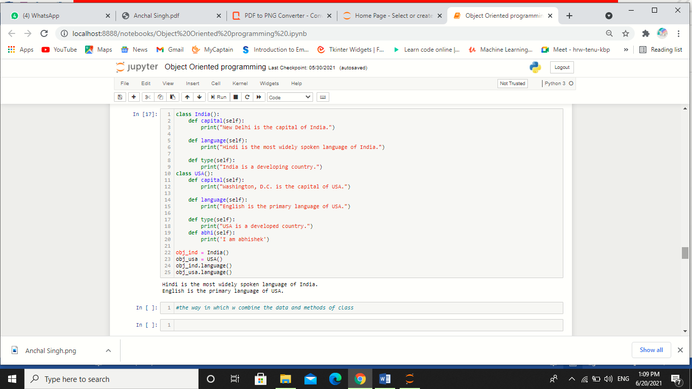

**8.5 Encapsulation**

When working with classes and dealing with sensitive data, providing global access to all the variables used within the program is not a good choice. Encapsulation offers a way for us to access the required variables without providing the program full-fledged access to any of those variables.

Updating, modifying, or deleting data from variables can be done through the use of methods that are defined specifically for the purpose. The benefit of using this approach to programming is improved control over the input data and better security.

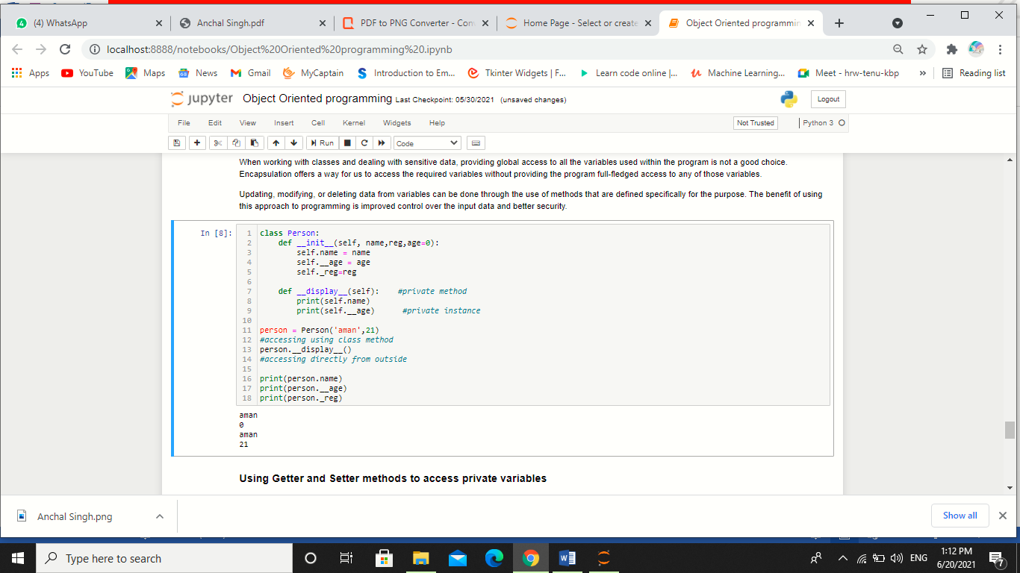

**Chapter-9**

**9.1 Graphical User Interface (GUI) Programming**

Tkinter Programming Tkinter is the standard GUI library for Python. Python when combined with Tkinter provides a fast and easy way to create GUI applications. Tkinter provides a powerful object-oriented interface to the Tk GUI toolkit.

Creating a GUI application using Tkinter is an easy task. All you need to do is perform the following steps −

**Import the Tkinter module.**

Create the GUI application main window.

Add one or more of the above-mentioned widgets to the GUI application.

Enter the main event loop to take action against each event triggered by the user.

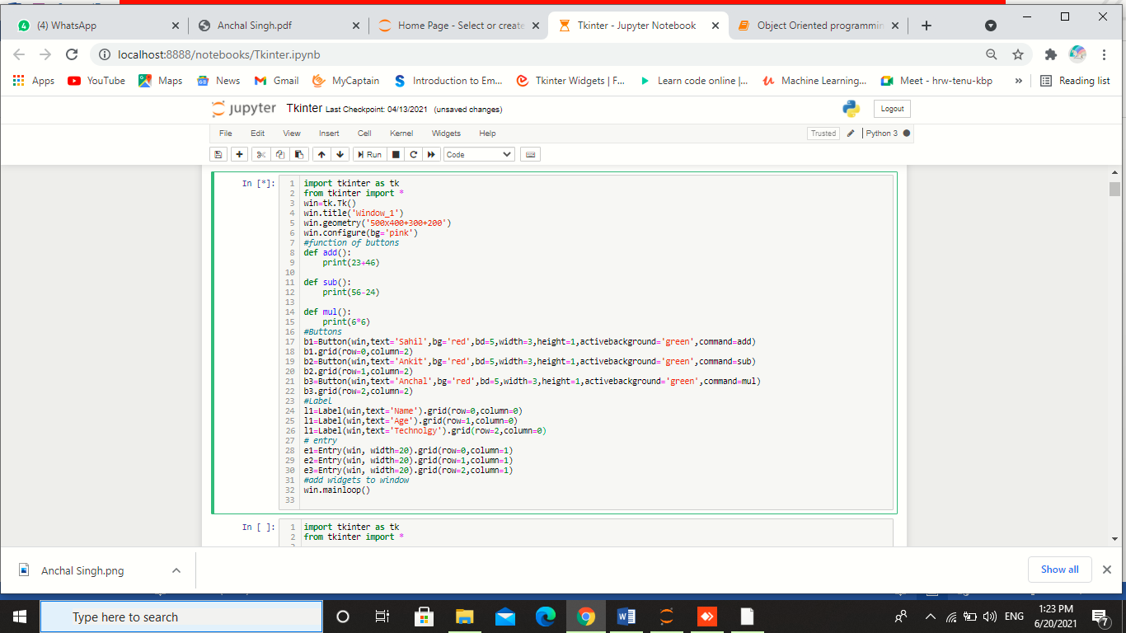

**Figure 13: Simple GUI**

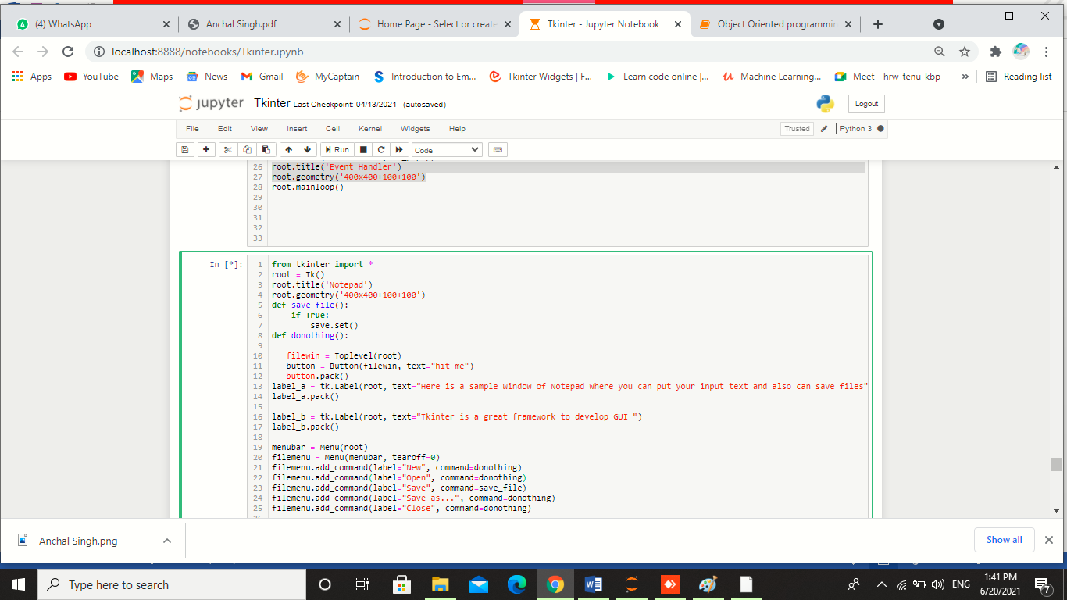

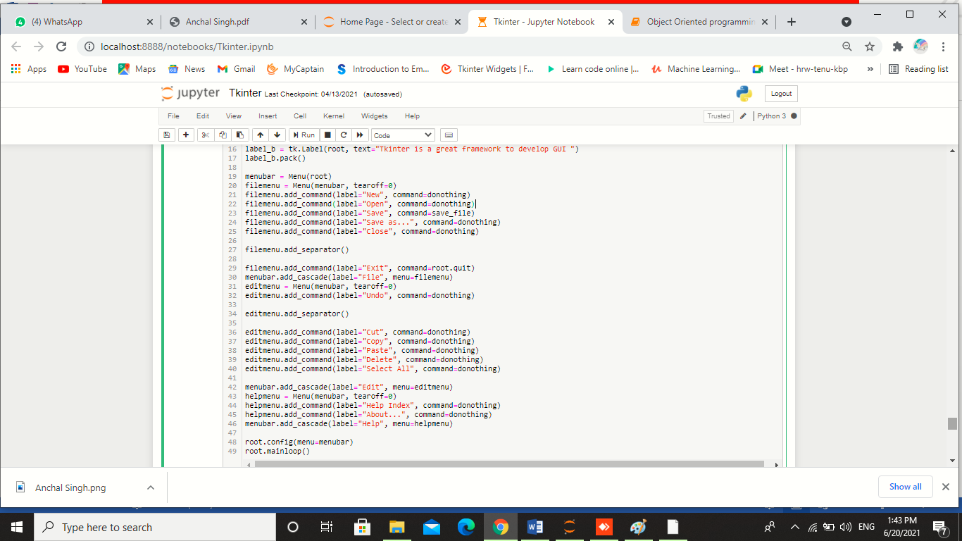

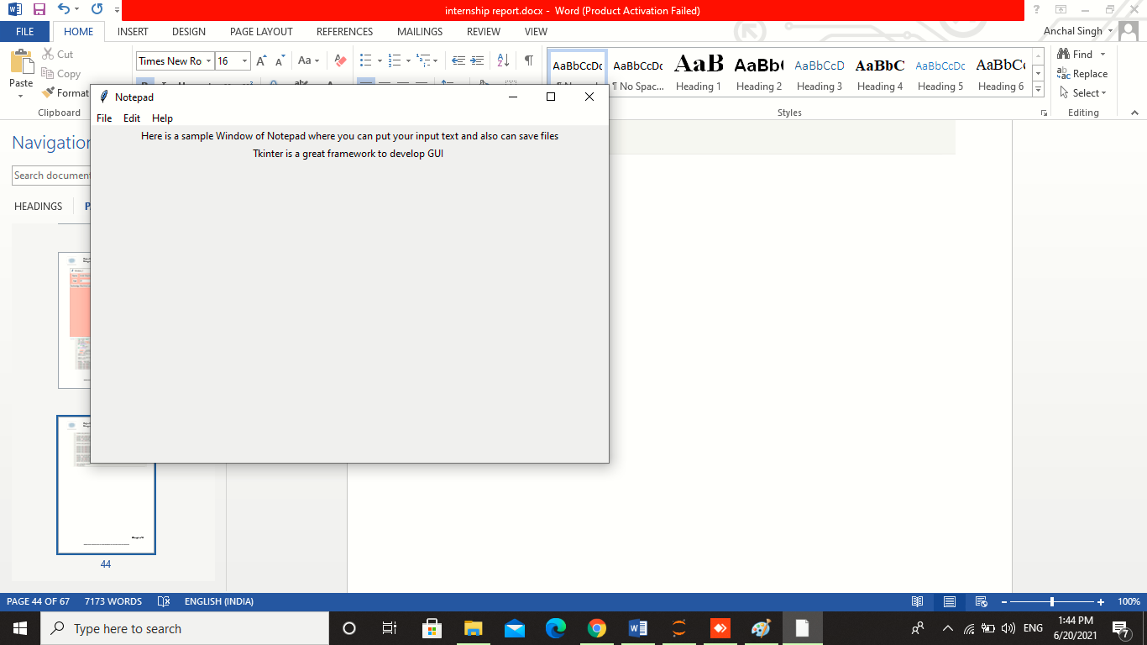

Figure 14: Notepad GUI

**Chapter-10**

**10.1 Data Visualisation using Matplotlib:**

**Matplotlib** is one of the most popular Python packages used for data visualization. It is a cross-platform library for making 2D plots from data in arrays. Matplotlib is written in Python and makes use of NumPy, the numerical mathematics extension of Python. It provides an object-oriented API that helps in embedding plots in applications using Python GUI toolkits such as PyQt, WxPythonotTkinter.  
It can be used in Python and IPython shells, Jupyter notebook and web application servers also.

Matplotlib has a procedural interface named the Pylab, which is designed to resemble MATLAB, a proprietary programming language developed by MathWorks. Matplotlib along with NumPy can be considered as the open source equivalent of MATLAB.

Matplotlib was originally written by John D. Hunter in 2003. The current stable version is 2.2.0 released in January 2018.

**10.2 Sinusoidal plot**

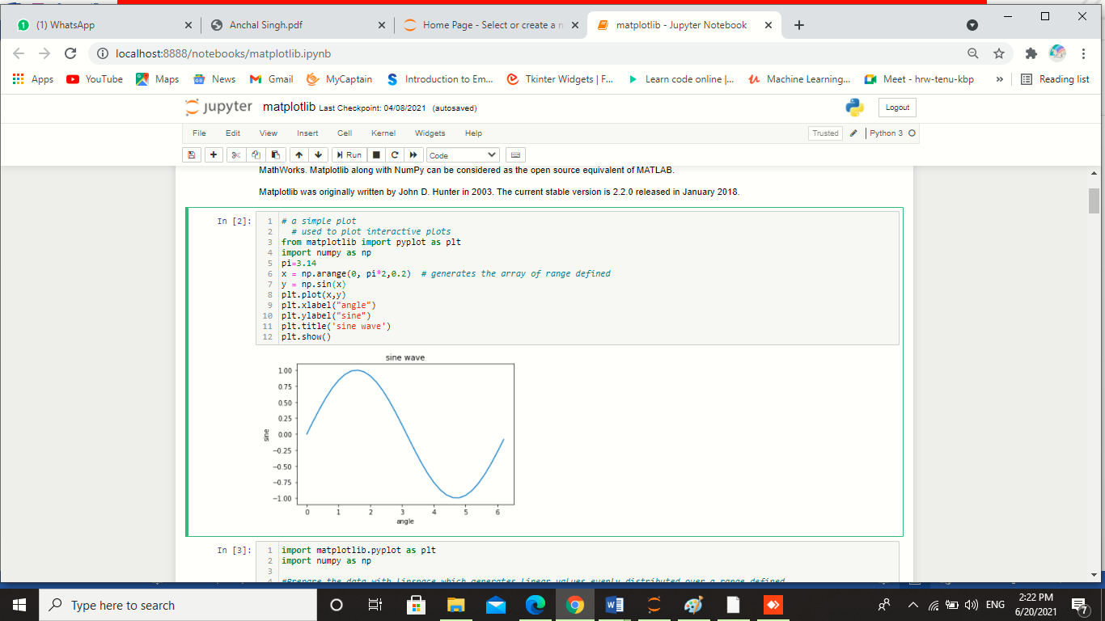

Figure 15: Simple sinusoidal plot

**10.3 Parabolic Plot**

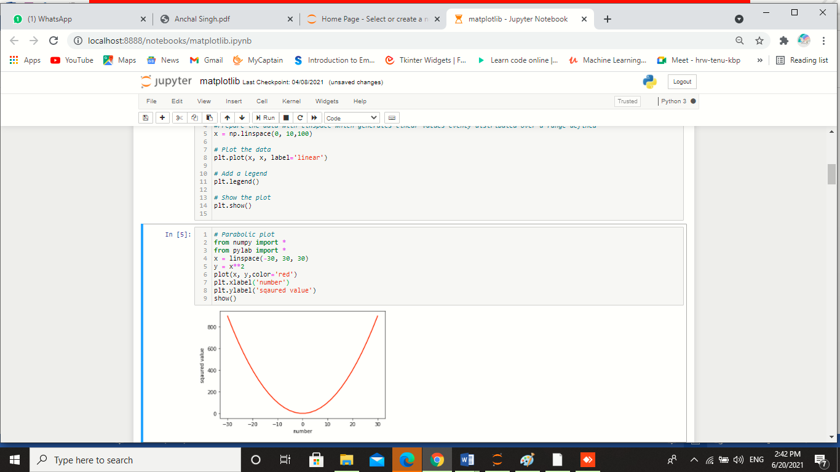

Figure 16: Parabolic plot

**10.3 Subplots on single Axis**

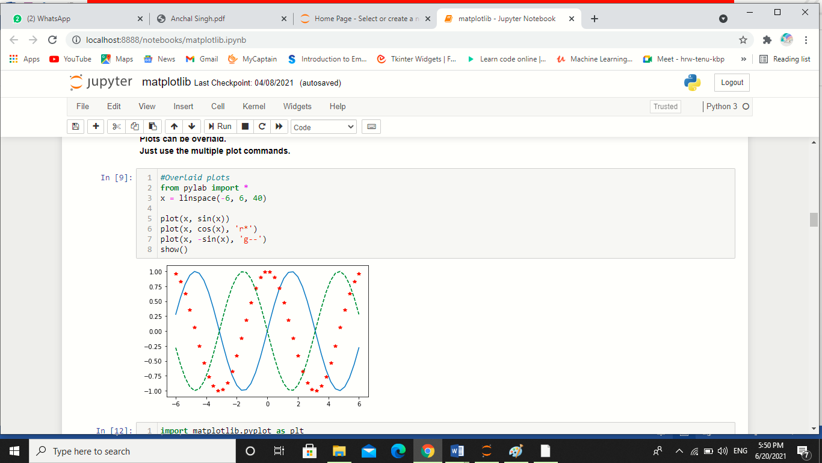

Figure 17: Overlaid plots

**10.4 Bar Plots**

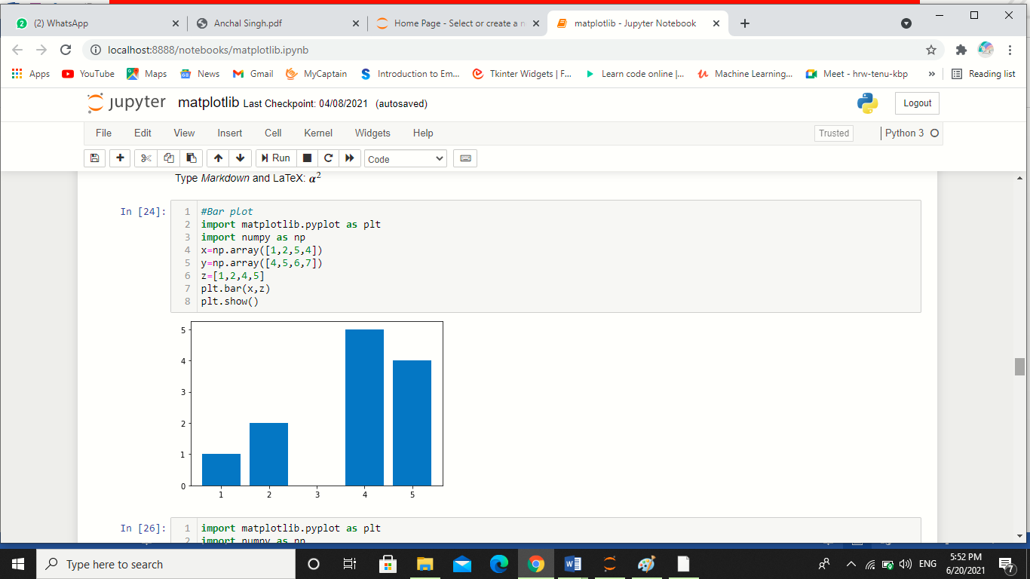

Figure 18: bar plot

**10.5 Histogram plots**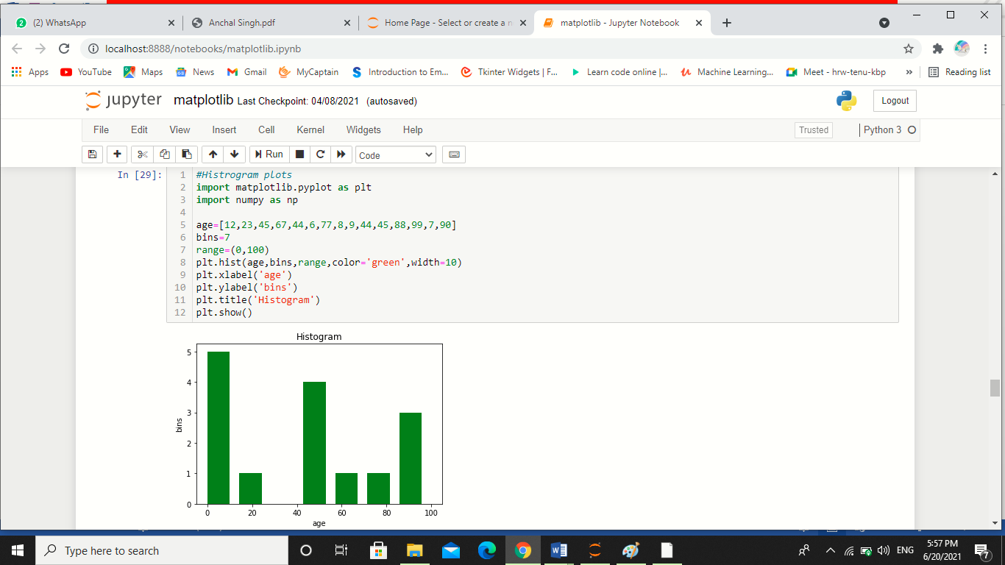

Figure 19: Histogram plot

**10.6 Scatter Plots**

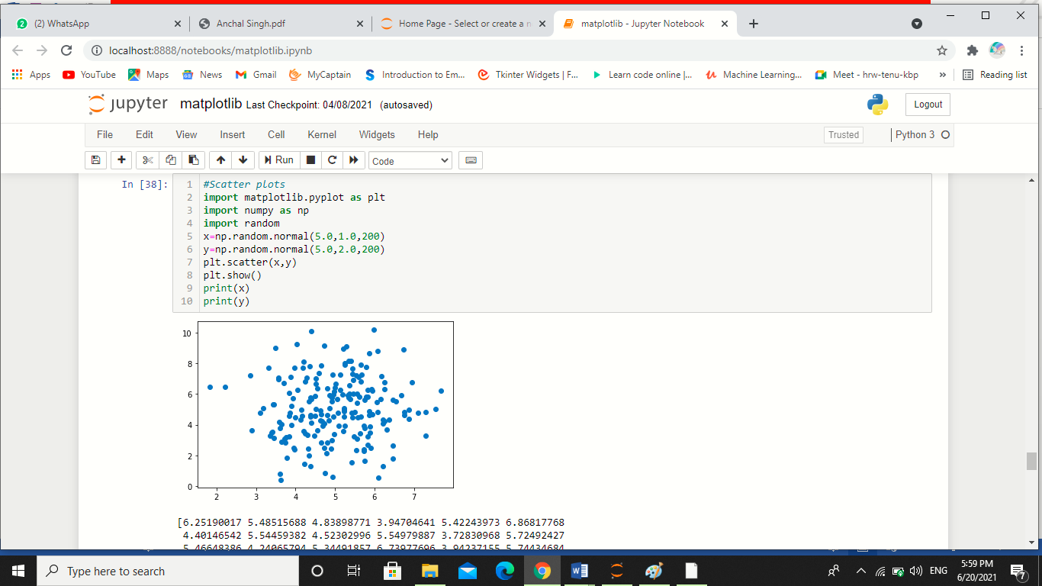

Figure 20: Scatter plot

**Chapter-11**

**11.1 Data Visualisation using Pandas:**

Pandas is an open-source Python Library providing high-performance data manipulation and analysis tool using its powerful data structures

Key Features of Pandas

* Fast and efficient DataFrame object with default and customized indexing.
* Tools for loading data into in-memory data objects from different file formats.
* Data alignment and integrated handling of missing data.
* Reshaping and pivoting of date sets.
* Label-based slicing, indexing and sub setting of large data sets.
* Columns from a data structure can be deleted or inserted.
* Group by data for aggregation and transformations.
* High performance merging and joining of data.
* Time Series functionality.

**11.2 Setting up Pandas with first code**

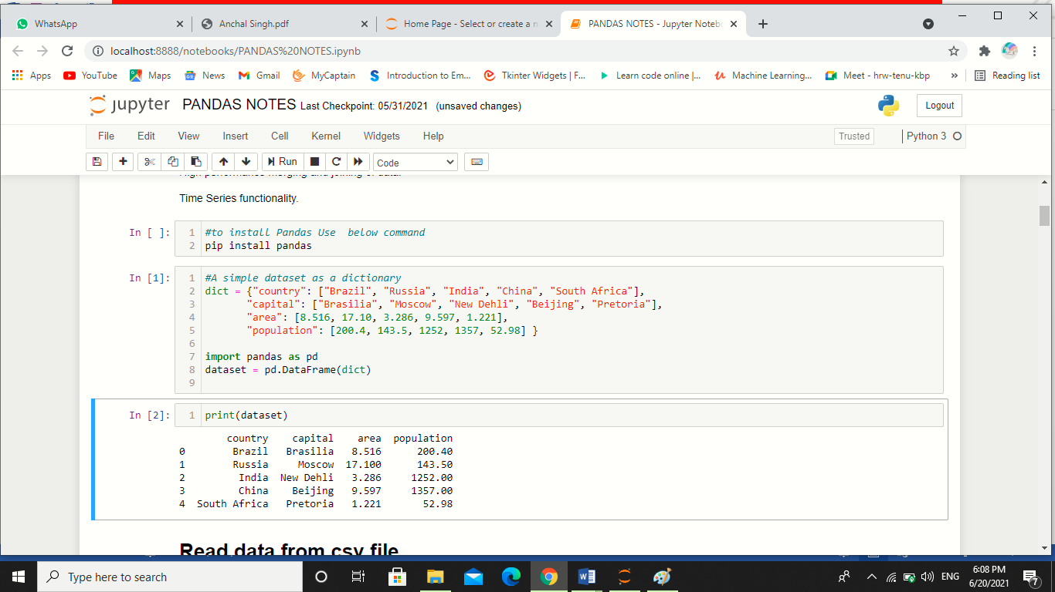

**11.3 Read data from csv file:**

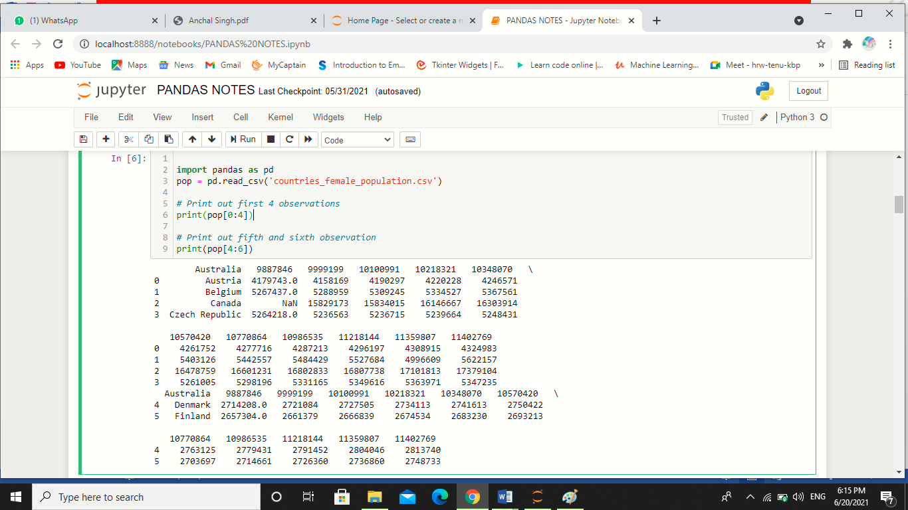

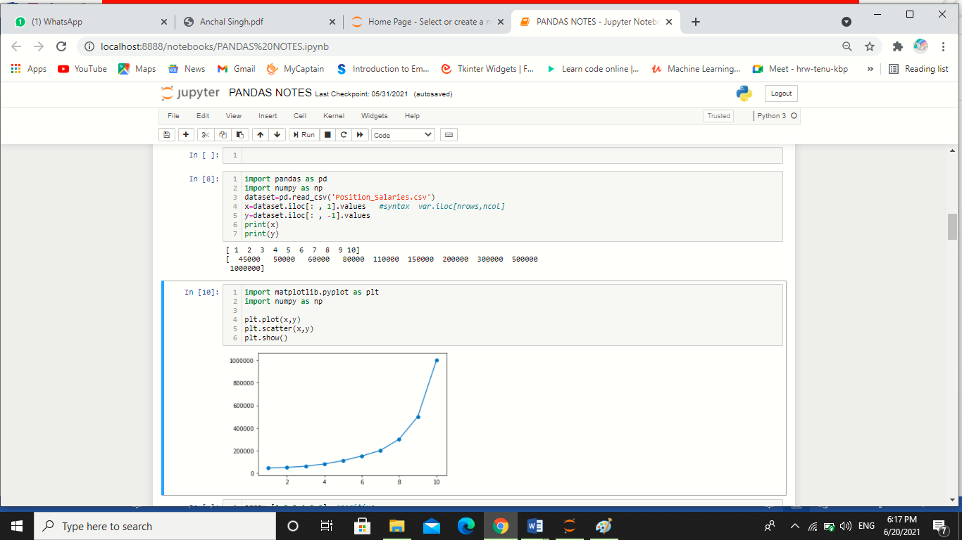

**Reading Country_female_popultion dataset:**

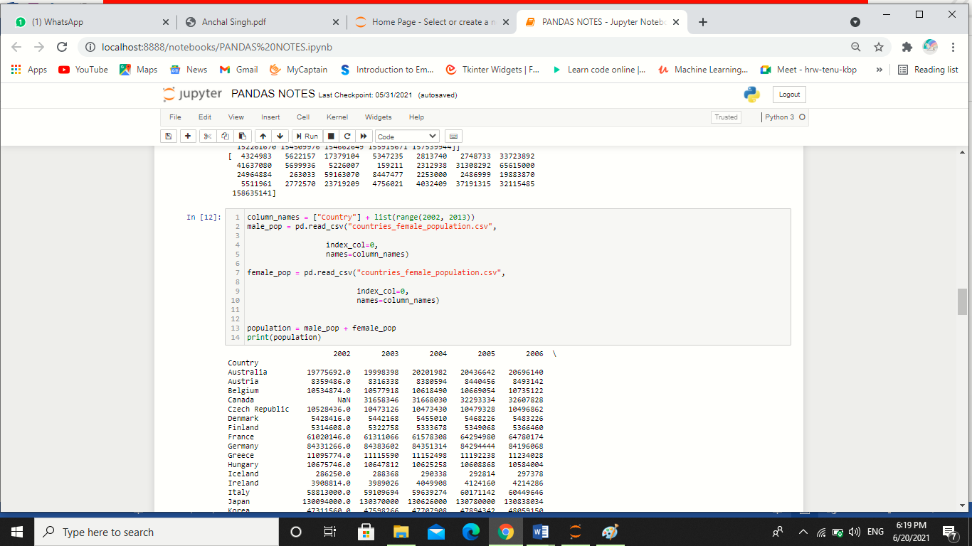

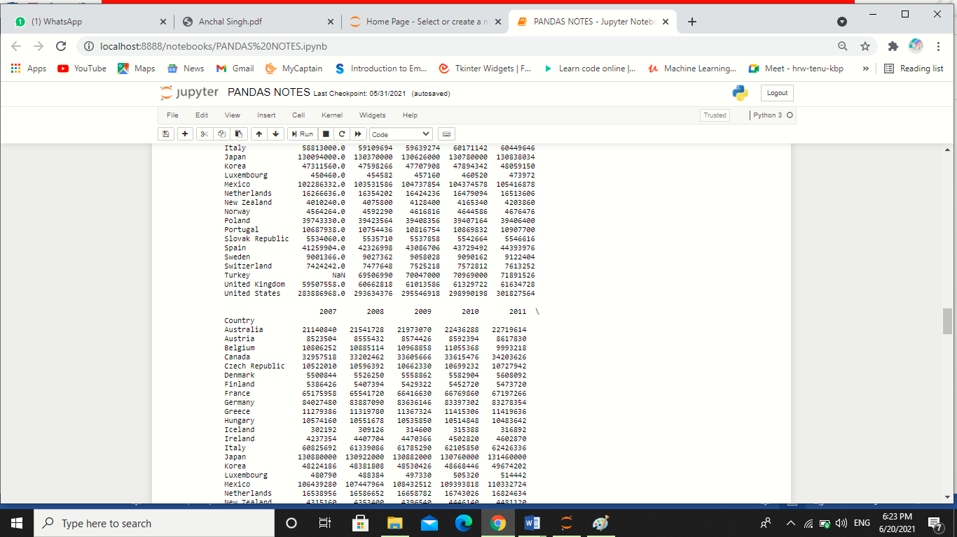

**11.4 Reading data from text files:**

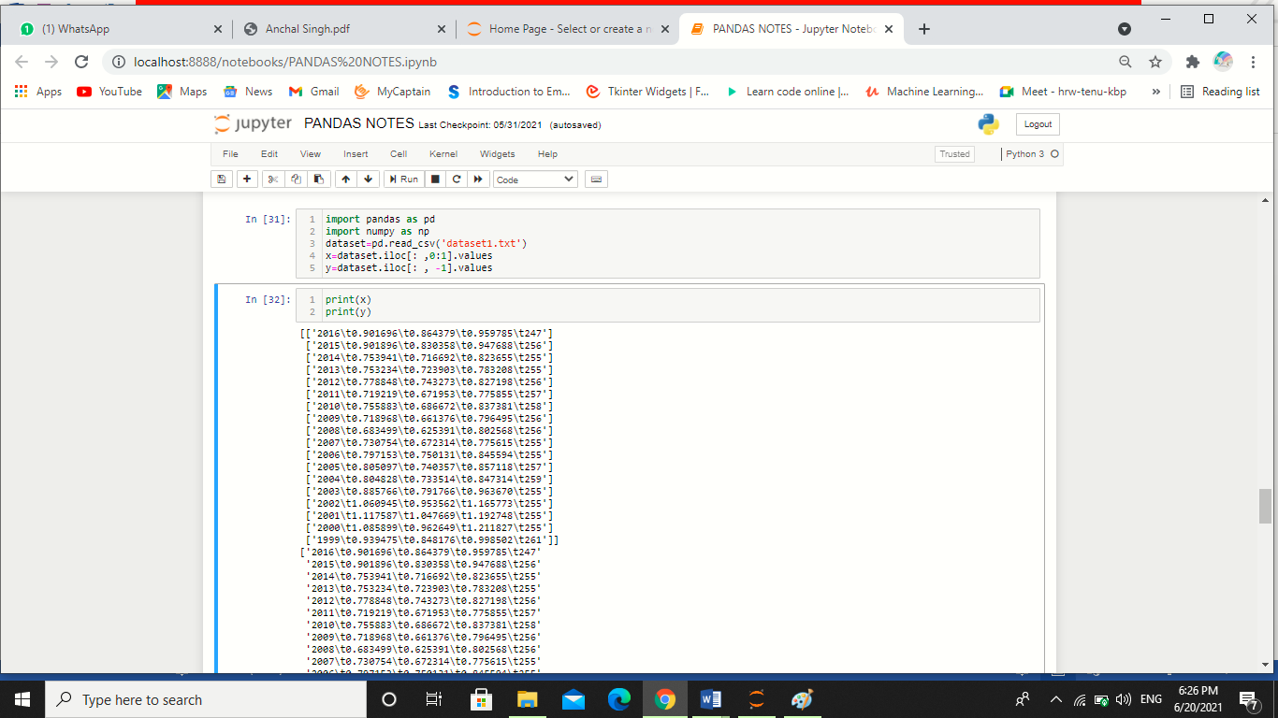

**Chapter-13**

**13.1 Introduction to Machine Learning:**

Machine Learning is the most popular technique of predicting the future or classifying information to help people in making necessary decisions. Machine Learning algorithms are trained over instances or examples through which they learn from past experiences and also analyse the historical data. Therefore, as it trains over the examples, again and again, it is able to identify patterns in order to make predictions about the future.

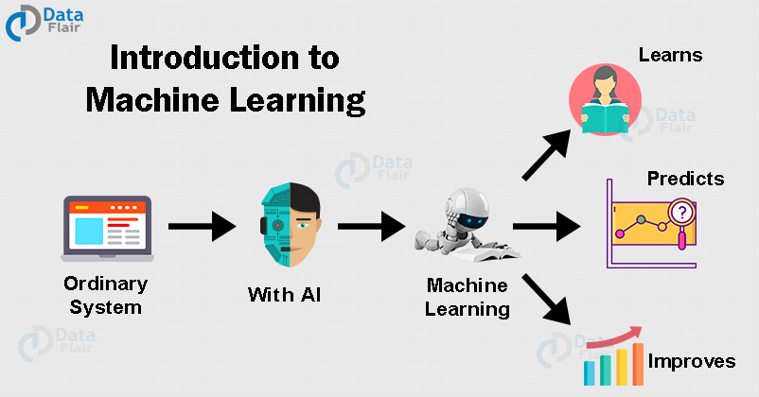

Figure 26: Machine learning process overview

**13.2 Machine Learning – Types of Techniques:**

**There are**three types of ML Techniques:

* + 1. **Supervised Learning:-**Supervised learning as the name suggests getting supervised by someone. It is a learning in which the machine uses data which is already tagged with the correct answer. After that, the machine is provided with a new set of data. With the help of supervised learning, the algorithm analyses the training data (set of training examples) and produces a correct outcome from labelled data. Here the machine has already learned the things from previous data. So, now is the time it uses the learning wisely.

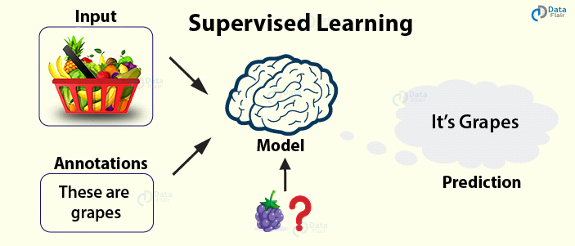 Figure 26: Supervised learning process overview

**For example –** if we take a fruit basket, the machine will first classify the fruit with its shape and colour and would confirm the fruit name. If one searches for grapes, then machine learning from its training data (basket containing fruits) will use the prior knowledge.

It will then apply the knowledge to test data and will then provide you with the results.

* + 1. **Unsupervised Learning:-** In unsupervised learning, the training of the machine is done using the information which is neither classified nor labelled. The machine learning algorithm acts on information without guidance. It groups unsorted information according to similarities, patterns, and differences without any prior training or supervision. Since there is no training given to the machine, the machine itself finds the hidden structure in unlabelled data and interprets it.

**For example –** a wooden stick with a cap can be a pen and with no cap a pencil. With no learning and no training, the machine tries to interpret itself.

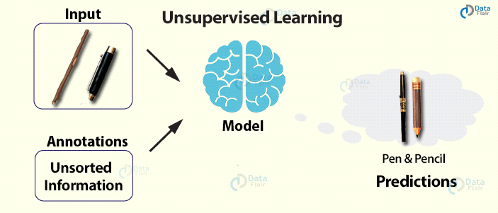

Figure 28: Unsupervised learning process overview

* + 1. **Reinforcement Learning:-** Reinforcement learning is a very interesting kind of learning. There’s no answer key which can tell what’s right. But, the reinforcement learning agent still decides how to act to perform its task. This machine learning technique is all about taking actions that are suitable and maximize the reward in a particular situation. It is when the learner receives rewards and punishments for their actions.

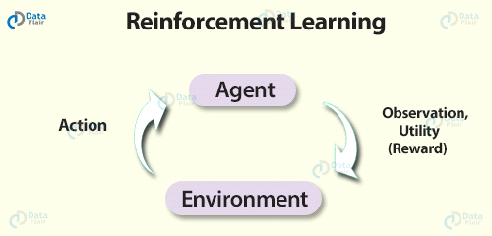 Figure 29:Reinforcement learning process overview

**For example –** In a given scenario, the reward could be utility and the agent could be told to receive as much utility as possible in order to “win”.

**13.3 Advantages of Machine learning:**

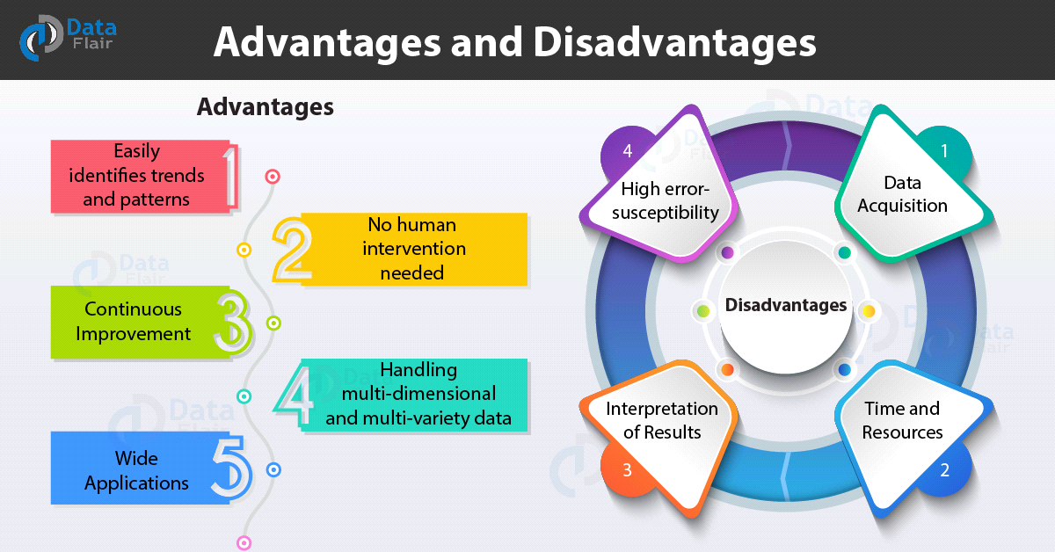

Figure 30:Advantages of Machine learning

* + 1. **Easily identifies trends and patterns:-**

Machine Learning can review large volumes of data and discover specific trends and patterns that would not be apparent to humans. For instance, for an e-commerce website like Amazon, it serves to understand the browsing behaviours and purchase histories of its users to help cater to the right products, deals, and reminders relevant to them. It uses the results to reveal relevant advertisements to them.

* + 1. **No human intervention needed (automation):-**

With ML, you don’t need to babysit your project every step of the way. Since it means giving machines the ability to learn, it lets them make predictions and also improve the algorithms on their own. A common example of this is anti-virus software’s they learn to filter new threats as they are recognized. ML is also good at recognizing spam.

* + 1. **Continuous Improvement:-**

As [ML algorithms](https://data-flair.training/blogs/machine-learning-algorithms/) gain experience, they keep improving in accuracy and efficiency. This lets them make better decisions. Say you need to make a weather forecast model. As the amount of data you have keeps growing, your algorithms learn to make more accurate predictions faster.

* + 1. **Handling multi-dimensional and multi-variety data:-**

Machine Learning algorithms are good at handling data that are multi-dimensional and multi-variety, and they can do this in dynamic or uncertain environments.

* + 1. **Wide Applications:-**

You could be an e-trailer or a healthcare provider and make ML work for you. Where it does apply, it holds the capability to help deliver a much more personal experience to customers while also targeting the right customers.

**13.4 Disadvantages of Machine Learning:**

With all those advantages to its powerfulness and popularity, Machine Learning isn’t perfect. The following factors serve to limit it:

**13.4.1 .Data Acquisition:-**

Machine Learning requires massive data sets to train on, and these should be inclusive/unbiased, and of good quality. There can also be times where they must wait for new data to be generated.

* + 1. **Time and Resources:-**

ML needs enough time to let the algorithms learn and develop enough to fulfil their purpose with a considerable amount of accuracy and relevancy. It also needs massive resources to function. This can mean additional requirements of computer power for you.

* + 1. **Interpretation of Results:-**

Another major challenge is the ability to accurately interpret results generated by the algorithms. You must also carefully choose the algorithms for your purpose.

* + 1. **High error-susceptibility:-**

[Machine Learning](https://en.wikipedia.org/wiki/Machine_learning) is autonomous but highly susceptible to errors. Suppose you train an algorithm with data sets small enough to not be inclusive. You end up with biased predictions coming from a biased training set. This leads to irrelevant advertisements being displayed to customers. In the case of ML, such blunders can set off a chain of errors that can go undetected for long periods of time. And when they do get noticed, it takes quite some time to recognize the source of the issue, and even longer to correct it.

**13.5 Introduction to Artificial Intelligence**

Artificial Intelligence is an approach to make a computer, a robot, or a product to think how smart human think. AI is a study of how human brain think, learn, decide and work, when it tries to solve problems. And finally this study outputs intelligent software systems. The aim of AI is to improve computer functions which are related to human knowledge, for example, reasoning, learning, and problem-solving.

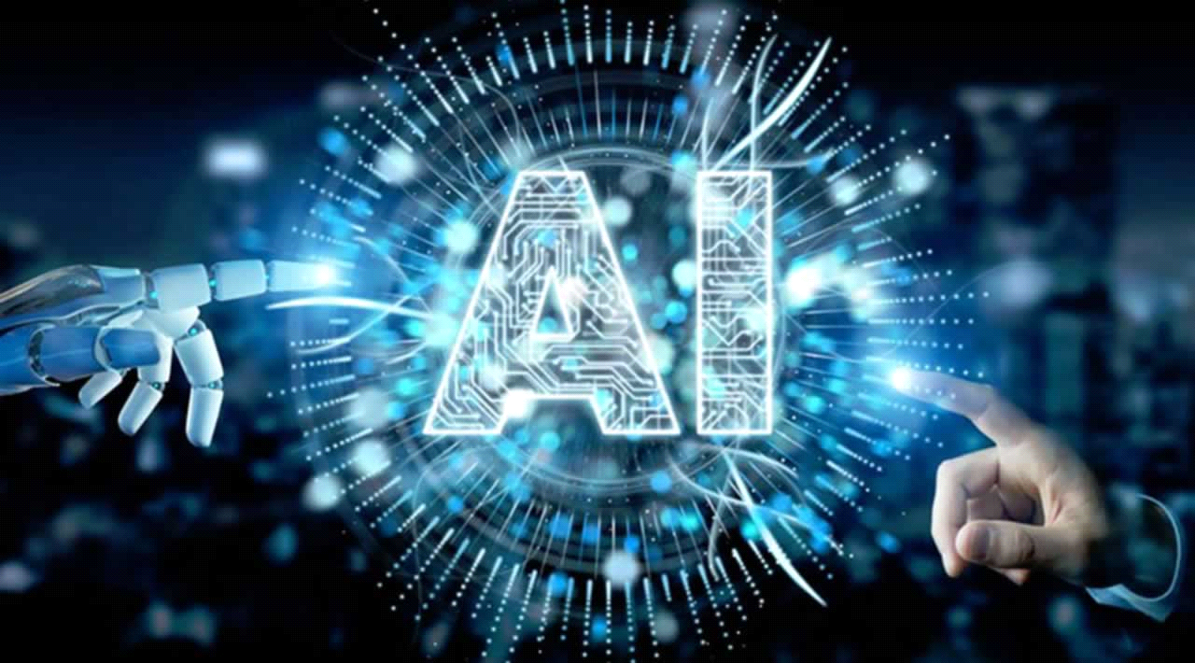

Figure 31:Artificial intelligence overview

The intelligence is intangible. It is composed of

* Reasoning
* Learning
* Problem Solving
* Perception
* Linguistic Intelligence

The objectives of AI research are reasoning, knowledge representation, planning, learning, natural language processing, realization, and ability to move and manipulate objects. There are long-term goals in the general intelligence sector. Approaches include statistical methods, computational intelligence, and traditional coding AI. During the AI research related to search and mathematical optimization, artificial neural networks and methods based on statistics, probability, and economics, we use many tools. Computer science attracts AI in the field of science, mathematics, psychology, linguistics, philosophy and so on.

**13.6 Applications of AI**

**· Gaming −** AI plays important role for machine to think of large number of possible positions based on deep knowledge in strategic games. for example, chess, river crossing, N-queens problems and etc.

**Natural Language Processing −** Interact with the computer that understands natural language spoken by humans.

**Expert Systems** − Machine or software provide explanation and advice to the users.

**Vision Systems** − Systems understand, explain, and describe visual input on the computer.

**Speech Recognition** − There are some AI based speech recognition systems have ability to hear and express as sentences and understand their meanings while a person talks to it. For example Siri and Google assistant.

**Handwriting Recognition** − The handwriting recognition software reads the text written on paper and recognize the shapes of the letters and convert it into editable text.

**Intelligent Robots** − Robots are able to perform the instructions given by a human.

Major Goals

Knowledge reasoning

Planning

Machine Learning

Natural Language Processing

Computer Vision

Robotics

**13.7 Advantages of AI**

**13.7.1 Reduction in Human Error:**

The phrase “**human error**” was born because humans make mistakes from time to time. Computers, however, do not make these mistakes if they are programmed properly. With Artificial intelligence, the decisions are taken from the previously gathered information applying a certain set of algorithms. So errors are reduced and the chance of reaching accuracy with a greater degree of precision is a possibility.

**Example:**In Weather Forecasting using AI they have reduced the majority of human error.

**13.7.2 Takes risks instead of Humans:**

This is one of the biggest advantages of Artificial intelligence. We can overcome many risky limitations of humans by developing an AI Robot which in turn can do the risky things for us. Let it be going to mars, defuse a bomb, explore the deepest parts of oceans, mining for coal and oil, it can be used effectively in any kind of natural or man-made disasters.

**Example:**Have you heard about the **Chernoby**l nuclear power plant explosion in Ukraine? At that time there were no AI-powered robots that can help us to minimize the effect of radiation by controlling the fire in early stages, as any human went close to the core was dead in a matter of minutes. They eventually poured sand and boron from helicopters from a mere distance.

AI Robots can be used in such situations where intervention can be hazardous.

**13.7.3 Available 24x7:**

An Average human will work for 4–6 hours a day excluding the breaks. Humans are built in such a way to get some time out for refreshing themselves and get ready for a new day of work and they even have weekly offed to stay intact with their work-life and personal life. But using AI we can make machines work 24x7 without any breaks and they don’t even get bored, unlike humans.

**Example:**Educational Institutes and Helpline centres are getting many queries and issues which can be handled effectively using AI.

**13.7.4 Helping in Repetitive Jobs:**

In our day-to-day work, we will be performing many repetitive works like sending a thanking mail, verifying certain documents for errors and many more things. Using artificial intelligence we can productively automate these mundane tasks and can even remove “**boring**” tasks for humans and free them up to be increasingly creative.

**Example:**In banks, we often see many verifications of documents to get a loan which is a repetitive task for the owner of the bank. Using AI Cognitive Automation the owner can speed up the process of verifying the documents by which both the customers and the owner will be benefited.

**13.7.5 Digital Assistance:**

Some of the highly advanced organizations use digital assistants to interact with users which saves the need for human resources. The digital assistants also used in many websites to provide things that users want. We can chat with them about what we are looking for. Some chatbots are designed in such a way that it’s become hard to determine that we’re chatting with a chatbot or a human being.

**Example:**We all know that organizations have a customer support team that needs to clarify the doubts and queries of the customers. Using AI the organizations can set up a Voice bot or Chatbot which can help customers with all their queries. We can see many organizations already started using them on their websites and mobile applications.

**13.7.6 Faster Decisions:**

Using AI alongside other technologies we can make machines take decisions faster than a human and carry out actions quicker. While taking a decision human will analyse many factors both emotionally and practically but AI-powered machine works on what it is programmed and delivers the results in a faster way.

**Example:**We all have played Chess games in Windows. It is nearly impossible to beat CPU in the hard mode because of the AI behind that game. It will take the best possible step in a very short time according to the algorithms used behind it.

**13.7.7 Daily Applications:**

Daily applications such as Apple’s **Siri**, Window’s **Cortana**, Google’s **OK Google** are frequently used in our daily routine whether it is for searching a location, taking a selfie, making a phone call, replying to a mail and many more.

**Example:**Around 20 years ago, when we are planning to go somewhere we used to ask a person who already went there for the directions. But now all we have to do is say “**OK Google**where is Visakhapatnam”. It will show you Visakhapatnam’s location on google map and the best path between you and Visakhapatnam.

**13.7.8 New Inventions:**

AI is powering many inventions in almost every domain which will help humans solve the majority of complex problems.

**Example:**Recently doctors can predict breast cancer in the woman at earlier stages using advanced AI-based technologies.

**13.8 Disadvantages of AI**

**13.8.1 High Costs of Creation:**

As AI is updating every day the hardware and software need to get updated with time to meet the latest requirements. Machines need repairing and maintenance which need plenty of costs. It’s creation requires huge costs as they are very complex machines.

**13.8.2 Making Humans Lazy:**

AI is making humans lazy with its applications automating the majority of the work. Humans tend to get **addicted**to these inventions which can cause a problem to future generations.

**13.8.3 Unemployment:**

As AI is replacing the majority of the repetitive tasks and other works with robots, human interference is becoming less which will cause a major problem in the employment standards. Every organization is looking to replace the minimum qualified individuals with AI robots which can do similar work with more efficiency.

**13.8.4 No Emotions:**

There is no doubt that machines are much better when it comes to working efficiently but they cannot replace the human connection that makes the team. Machines cannot develop a bond with humans which is an essential attribute when comes to Team Management.

**13.8.5 Lacking Out of Box Thinking:**

Machines can perform only those tasks which they are designed or programmed to do, anything out of that they tend to crash or give irrelevant outputs which could be a major backdrop.

**FACE DETECTION & FACE RECOGNITION**

**USING OPEN COMPUTER VISION**

**CLASSIFIRES**

1

**Abstract**

Identifying a person with an image has been popularised through the mass media. However, it is less robust to fingerprint or retina scanning. This report describes the face detection and recognition mini-project undertaken for the visual perception and autonomy module at Plymouth university. It reports the technologies available in the Open-Computer-Vision (OpenCV) library and methodology to implement them using Python. For face detection, Haar-Cascades were used and for face recognition Eigenfaces, Fisherfaces and Local binary pattern histograms were used. The methodology is described including flow charts for each stage of the system. Next, the results are shown including plots and screen-shots followed by a discussion of encountered challenges. The report is concluded with the authors’ opinion on the project and possible applications.

# 1 Introduction

The following document is a report on the mini project for Robotic visual perception and autonomy. It involved building a system for face detection and face recognition using several classifiers available in the open computer vision library(OpenCV). Face recognition is a non-invasive identification system and faster than other systems since multiple faces can be analysed at the same time. The difference between face detection and identification is, face detection is to identify a face from an image and locate the face. Face recognition is making the decision ”whose face is it ? ”, using an image database. In this project both are accomplished using different techniques and are described below. The report begins with a brief history of face recognition. This is followed by the explanation of HAAR-cascades, Eigenface, Fisherface and Local binary pattern histogram (LBPH) algorithms. Next, the methodology and the results of the project are described. A discussion regarding the challenges and the resolutions are described. Finally, a conclusion is provided on the pros and cons of each algorithm and possible implementations.

# 2 The History of Face Recognition

Face recognition began as early as 1977 with the first automated system being introduced By Kanade using a feature vector of human faces [1]. In 1983, Sirovich and Kirby introduced the principal component analysis(PCA) for feature extraction [2]. Using PCA, Turk and Pentland Eigenface was developed in 1991 and is considered a major milestone in technology [3]. Local binary pattern analysis for texture recognition was introduced in 1994 and is improved upon for facial recognition later by incorporating Histograms(LBPH) [4], [5]. In 1996 Fisherface was developed using Linear discriminant analysis ( LDA ) for dimensional reduction and can identify faces in different illumination conditions, which was an issue in Eigenface method [6]. Viola and Jones introduced a face detection technique using HAAR cascades and ADABoost [7]. In 2007, A face recognition technique was developed by Naruniec and Skarbek using Gabor Jets that are similar to mammalian eyes [8], [9]. In This project, HAAR cascades are used for face detection and Eigenface, Fisherface and LBPH are used for face recognition.

# 3 Face Detection using Haar-Cascades

A Haar wavelet is a mathematical fiction that produces square-shaped waves with a beginning and an end and used to create box shaped patterns to recognise signals with sudden transformations. An example is shown in figure 1. By combining several wavelets, a cascade can be created that can identify edges, lines and circles with different colour intensities. These sets are used in Viola Jones face detection technique in 2001 and since then more patterns are introduced [10] for object detection as shown in figure 1.

To analyse an image using Haar cascades, a scale is selected smaller than the target image. It is then placed on the image, and the average of the values of pixels in each section is taken. If the difference between two values pass a given threshold, it is considered a match. Face detection on a human face is performed by matching a combination of different Haar-like-features. For example, forehead, eyebrows and eyes contrast as well as the nose with eyes as shown below in figure A single classifier is not accurate enough. Several classifiers are combined as to provide an accurate face detection system as shown in the block diagram below in figure 3.

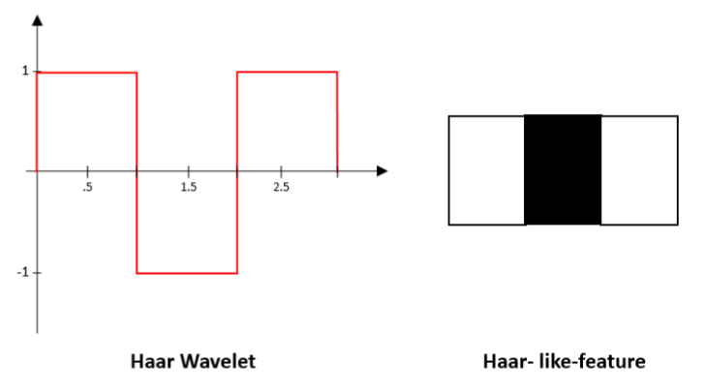 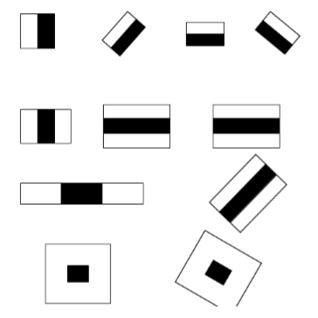

Figure 1: A Haar wavelet and resulting Haar-like features.

in this project, a similar method is used effectively to by identifying faces and eyes in combination resulting better face detection. Similarly, in viola Jones method [7], several classifies were combined to create stronger classifiers. ADA boost is a machine learning algorithm that tests out several week classifiers on a selected location and choose the most suitable [7]. It can also reverse the direction of the classifier and get better results if necessary [7]. 2. Furthermore, Weight-update-steps can be updated

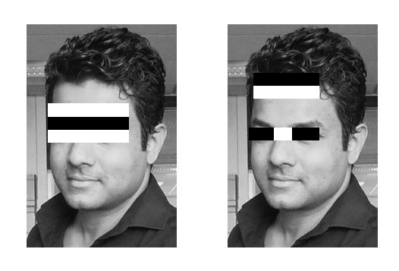

Figure 2: Several Haar-like-features matched to the features of authors face.

only on misses to get better performance. The cascade is scaled by 1.25 and re-iterated in order to find different sized faces. Running the cascade on an image using conventional loops takes a large amount of computing power and time. Viola Jones [7] used a summed area table (an integral image) to compute the matches fast. First developed in 1984 [11], it became popular after 2001 when Viola Jones implemented Haar-cascades for face detection. Using an integral image enables matching features with a single pass over the image.

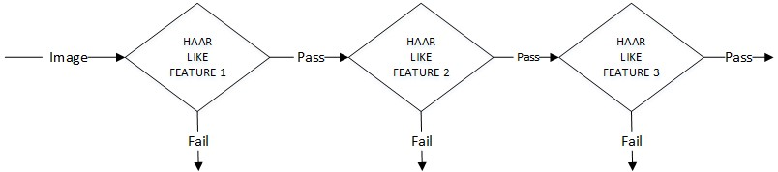

Figure 3: Haar-cascade flow chart

# 4 Face Recognition

The following sections describe the face recognition algorithms Eigenface, Fisherface, Local binary pattern histogram and how they are implemented in OpenCV.

### 4.1 Eigenface

Eigenface is based on PCA that classify images to extract features using a set of images. It is important that the images are in the same lighting condition and the eyes match in each image. Also, images used in this method must contain the same number of pixels and in grayscale. For this example, consider an image with n x n pixels as shown in figure 4. Each raw is concatenated to create a vector, resulting a 1×*n*2 matrix. All the images in the dataset are stored in a single matrix resulting a matrix with columns corresponding the number of images. The matrix is averaged (normalised) to get an average human face. By subtracting the average face from each image vector unique features to each face are computed. In the resulting matrix, each column is a representation of the difference each face has to the average human face. A simplified illustration can be seen in figure 4.

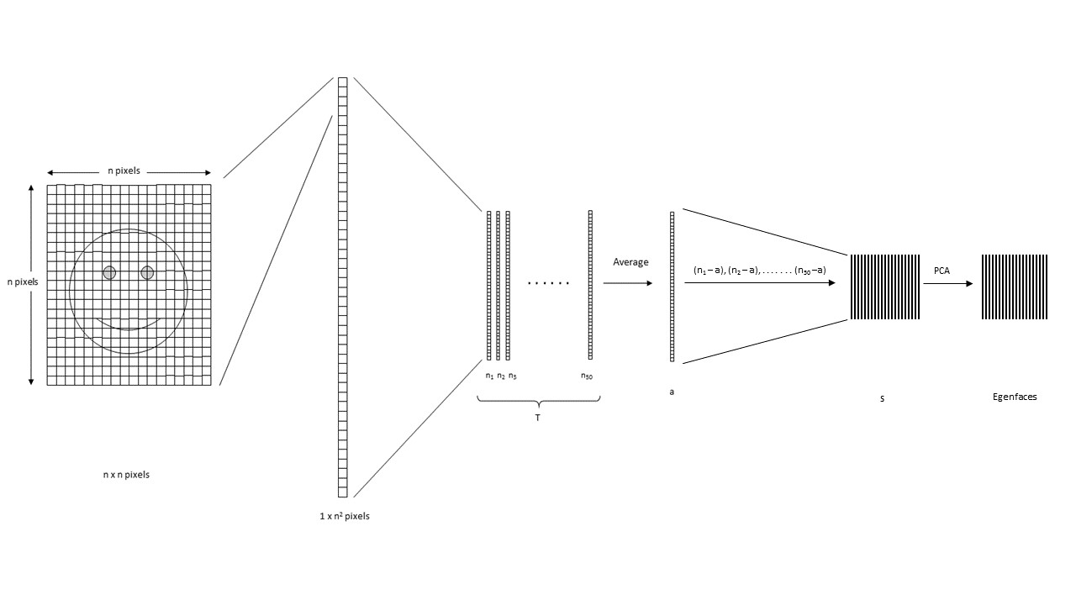

Figure 4: Pixels of the image are reordered to perform calculations for Eigenface

The next step is computing the covariance matrix from the result. To obtain the Eigen vectors from the data, Eigen analysis is performed using principal component analysis. From the result, where covariance matrix is diagonal, where it has the highest variance is considered the 1st Eigen vector. 2nd Eigen vector is the direction of the next highest variance, and it is in 90 degrees to the 1st vector. 3rd will be the next highest variation, and so on. Each column is considered an image and visualised, resembles a face and called Eigenfaces. When a face is required to be recognised, the image is imported, resized to match the same dimensions of the test data as mentioned above. By projecting extracted features on to each of the Eigenfaces, weights can be calculated. These weights correspond to the similarity of the features extracted from the different image sets in the dataset to the features extracted from the input image. The input image can be identified as a face by comparing with the whole dataset. By comparing with each subset, the image can be identified as to which person it belongs to. By applying a threshold detection and identification can be controlled to eliminate false detection and recognition. PCA is sensitive to large numbers and assumes that the subspace is linear. If the same face is analysed under different lighting conditions, it will mix the values when distribution is calculated and cannot be effectively classified. This makes to different lighting conditions poses a problem in matching the features as they can change dramatically.

### 4.2 Fisherface

Fisherface technique builds upon the Eigenface and is based on LDA derived from Ronald Fishers’ linear discriminant technique used for pattern recognition. However, it uses labels for classes as well as data point information [6]. When reducing dimensions, PCA looks at the greatest variance, while LDA, using labels, looks at an interesting dimension such that, when you project to that dimension you maximise the difference between the mean of the classes normalised by their variance [6]. LDA maximises the ratio of the between-class scatter and within-class scatter matrices. Due to this, different lighting conditions in images has a limited effect on the classification process using LDA technique. Eigenface maximises the variations while Fisherface maximises the mean distance between and different classes and minimises variation within classes. This enables LDA to differentiate between feature classes better than PCA and can be observed in figure 5 [12]. Furthermore, it takes less amount of space and is the fastest algorithm in this project. Because of these PCA is more suitable for representation of a set of data while LDA is suitable for classification.

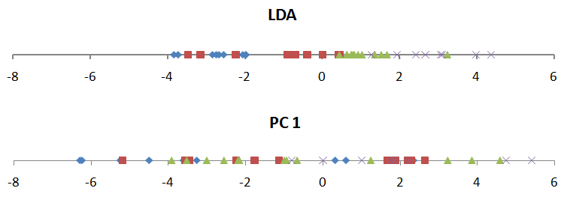

Figure 5: The first component of PCA and LDA. Classes in PCA looks more mixed than of LDA

### 4.3 Local Binary Pattern Histogram

Local binary patterns were proposed as classifiers in computer vision and in 1990 By Li Wang [4]. The combination of LBP with histogram oriented gradients was introduced in 2009 that increased its performance in certain datasets [5]. For feature encoding, the image is divided into cells (4 x 4 pixels). Using a clockwise or counter-clockwise direction surrounding pixel values are compared with the central as shown in figure 6. The value of intensity or luminosity of each neighbour is compared with the centre pixel. Depending if the difference is higher or lower than 0, a 1 or a 0 is assigned to the location. The result provides an 8-bit value to the cell. The advantage of this technique is even if the luminosity of the image

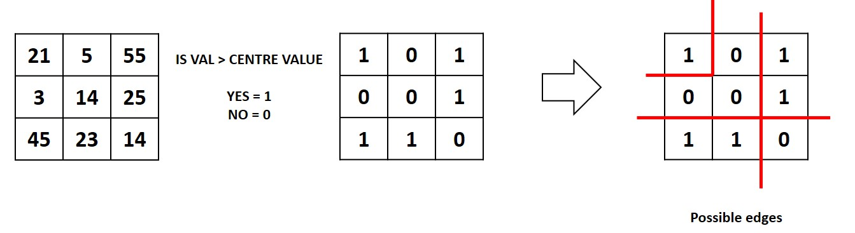

Figure 6: Local binary pattern histogram generating 8-bit number

is changed as in figure 7, the result is the same as before. Histograms are used in larger cells to find the frequency of occurrences of values making process faster. By analysing the results in the cell, edges can be detected as the values change. By computing the values of all cells and concatenating the histograms, feature vectors can be obtained. Images can be classified by processing with an ID attached. Input images are classified using the same process and compared with the dataset and distance is obtained. By setting up a threshold, it can be identified if it is a known or unknown face. Eigenface and Fisherface compute the dominant features of the whole training set while LBPH analyse them individually.

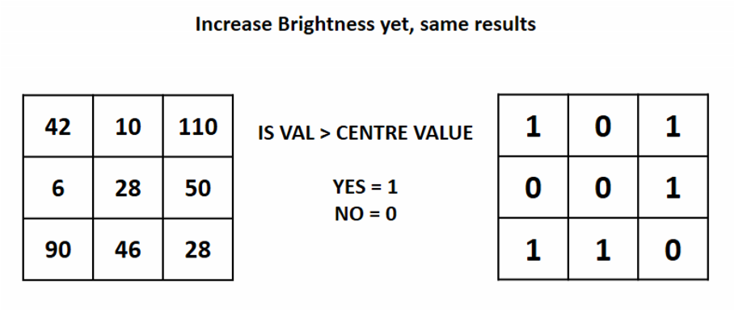

Figure 7: The results are same even if brightness is changed

# 5 Methodology

Below are the methodology and descriptions of the applications used for data gathering, face detection, training and face recognition. The project was coded in Python using a mixture of IDLE and PYCharm IDEs.

### 5.1 Face Detection

First stage was creating a face detection system using Haar-cascades. Although, training is required for creating new Haar-cascades, OpenCV has a robust set of Haar-cascades that was used for the project. Using face-cascades alone caused random objects to be identified and eye cascades were incorporated to obtain stable face detection. The flowchart of the detection system can be seen in figure 8. Face and eye

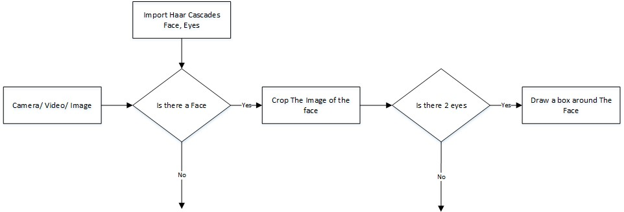

Figure 8: The Flow chart of the face detection application

classifier objects are created using classifier class in OpenCV through the **cv2.CascadeClassifier()** and loading the respective XML files. A camera object is created using the **cv2.VideoCapture()** to capture images. By using the **CascadeClassifier.detectMultiScale()** object of various sizes are matched and location is returned. Using the l

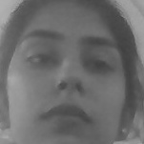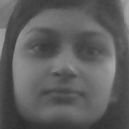

location data, the face is cropped for further verification. Eye cascade is used to verify there are two eyes in the cropped face. If satisfied a marker is placed around the face to illustrate a face is detected in the location.

### 5.2 Face Recognition Process

For this project three algorithms are implemented independently. These are Eigenface, Fisherface and Linear binary pattern histograms respectively. All three can be implemented using OpenCV libraries. There are three stages for the face recognition as follows:

1. Collecting images IDs
2. Extracting unique features, classifying them and storing in XML files
3. Matching features of an input image to the features in the saved XML files and predict identity

**5.2.1 Collecting the image data**

Collecting classification images is usually done manually using a photo editing software to crop and resize photos. Furthermore, PCA and LDA requires the same number of pixels in all the images for the correct operation. This time consuming and a laborious task is automated through an application to collect 50 images with different expressions. The application detects suitable expressions between 300 ms, straightens any existing tilt and save them. The Flow chart for the application is shown in figure 9.

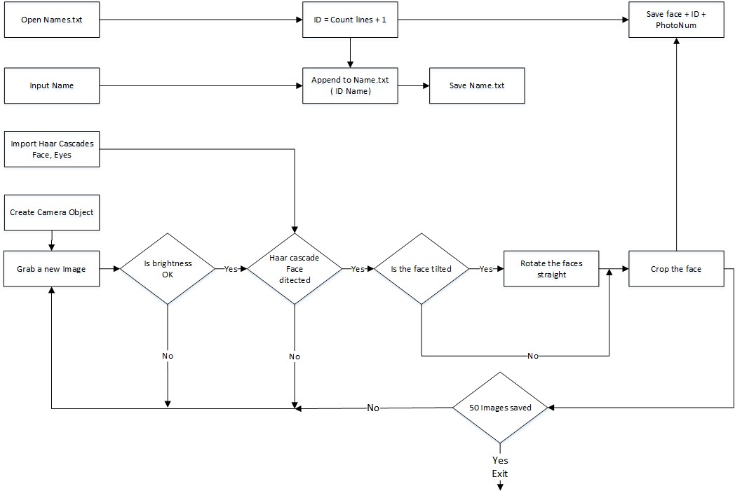

Figure 9: The Flowchart for the image collection

Application starts with a request for a name to be entered to be stored with the ID in a text file. The face detection system starts the first half. However, before the capturing begins, the application check for the brightness levels and will capture only if the face is well illuminated. Furthermore, after the face is detected, the position of the eyes are analysed. If the head is tilted, the application automatically corrects the orientation. These two additions were made considering the requirements for Eigenface algorithm. The Image is then cropped and saved using the ID as a filename to be identified later. A loop runs this program until 50 viable images are collected from the person. This application made data collection efficient.

**5.2.2 Training the Classifiers**

OpenCV enables the creation of XML files to store features extracted from datasets using the **FaceRecognizer** class. The stored images are imported, converted to grayscale and saved with IDs in two lists with same indexes. **FaceRecognizer** objects are created using face recogniser class. Each recogniser can take in parameters that are described below:

**cv2.face.createEigenFaceRecognizer()**

1. Takes in the number of components for the PCA for crating Eigenfaces. OpenCV documentation mentions 80 can provide satisfactory reconstruction capabilities.
2. Takes in the threshold in recognising faces. If the distance to the likeliest Eigenface is above this threshold, the function will return a -1, that can be used state the face is unrecognisable **cv2.face.createFisherfaceRecognizer()**
3. The first argument is the number of components for the LDA for the creation of Fisherfaces. OpenCV mentions it to be kept 0 if uncertain.
4. Similar to Eigenface threshold. -1 if the threshold is passed.

**cv2.face.createLBPHFaceRecognizer()**

1. The radius from the centre pixel to build the local binary pattern.
2. The Number of sample points to build the pattern. Having a considerable number will slow down the computer.
3. The Number of Cells to be created in X axis.
4. The number of cells to be created in Y axis.
5. A threshold value similar to Eigenface and Fisherface. if the threshold is passed the object will return -1

Recogniser objects are created and images are imported, resized, converted into numpy arrays and stored in a vector. The ID of the image is gathered from splitting the file name, and stored in another vector. By using **FaceRecognizer.train(NumpyImage, ID)** all three of the objects are trained. It must be noted that resizing the images were required only for Eigenface and Fisherface, not for LBPH. Next, the configuration model is saved as a XML file using **FaceRecognizer.save(FileName)**. In this project, all three are trained and saved through one application for convenience. The flow chart for the trainer is shown in figure 10.

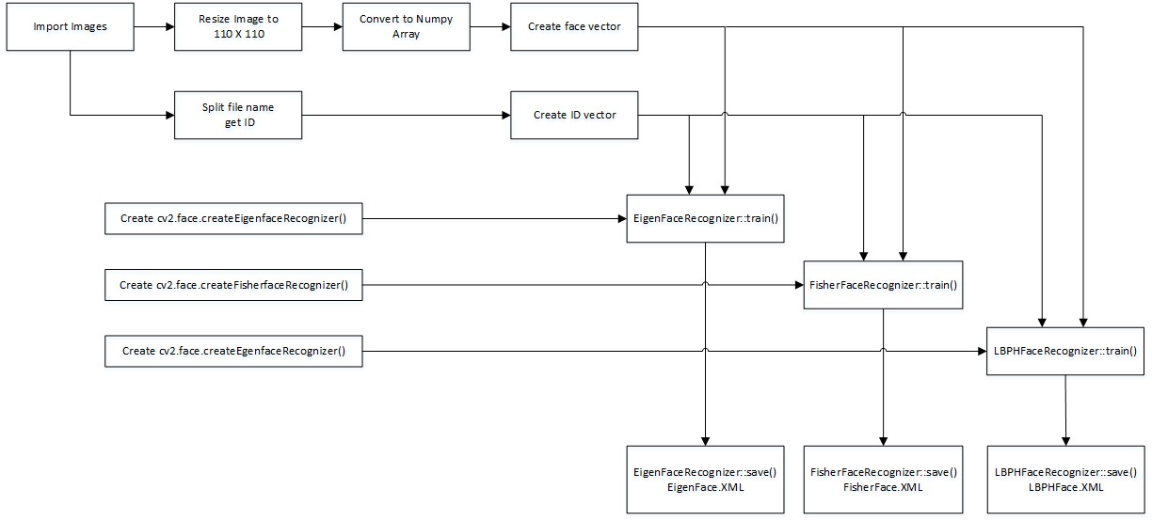

Figure 10: Flowchart of the training application

**5.2.3 The Face Recognition**

Face recogniser object is created using the desired parameters. Face detector is used to detect faces in the image, cropped and transferred to be recognised. This is done using the same technique used for the image capture application. For each face detected, a prediction is made using **FaceRecognizer.predict()** which return the ID of the class and confidence. The process is same for all algorithms and if the confidence his higher than the set threshold, ID is -1. Finally, names from the text file with IDs are used to display the name and confidence on the screen. If the ID is -1, the application will print unknown face without the confidence level. The flow chart for the application is shown in figure 11.

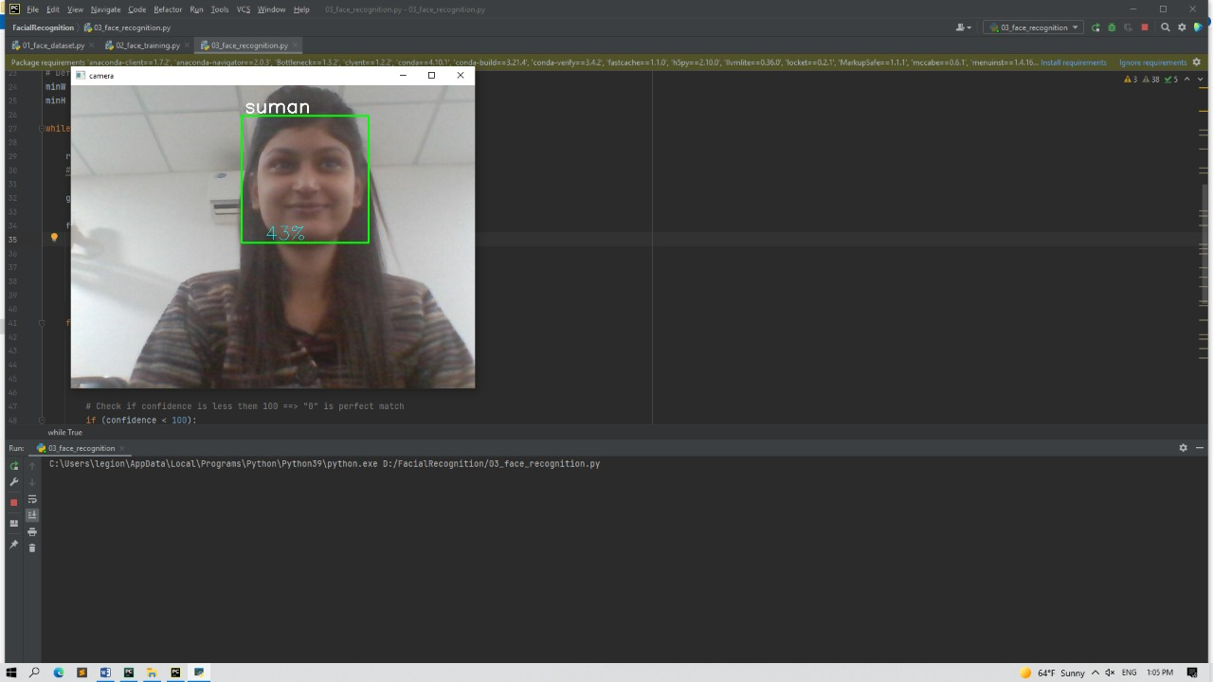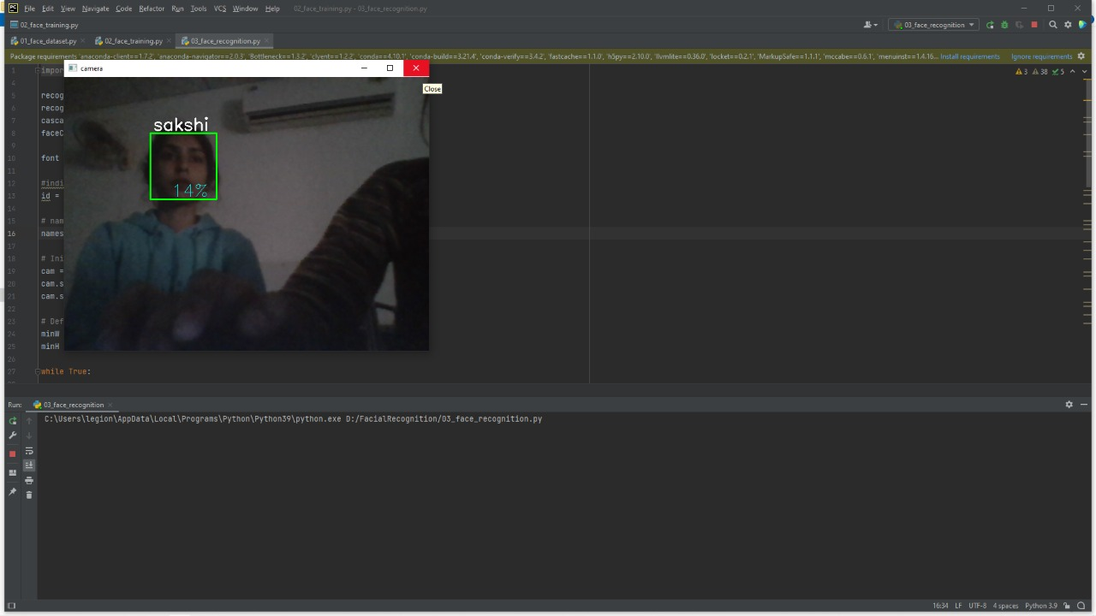

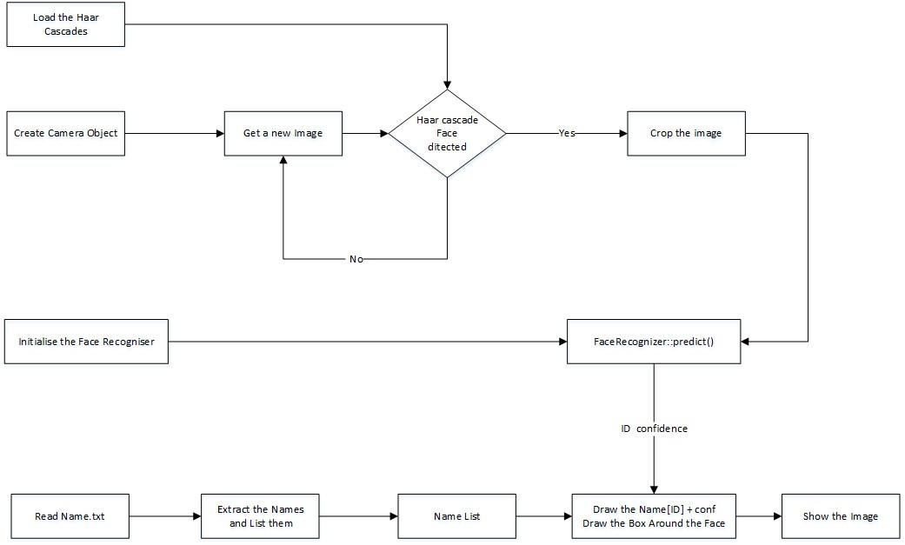

Figure 11: Flowchart of the face recognition application

# 6 Results

The collected images are shown below. Each face has 50 images. Three applications were written to iterate through the parameters of each algorithm. On each iteration, the algorithm is trained using different parameters and tested against a photo. The resulting data is plotted at the after finishing the tests. The applications are :

### Discussion

Early attempts on Eigenface and Fisherface was disappointing since the LBPH alone recognised a face. By designing an application to test the algorithms, and after calibration with new data, both algorithms performed well. The tester applications also allowed accurate threshold settings. Another problem was people tilting their head when images taken for the data. This was fixed with an application that identifies the locations of the eyes and rotate the image to correct the off-set. It was noticed that some early-stage images in the data-set different brightness’s. To resolve this, before taking an image, the brightness was averaged to prevent dark images. These changes to the system improved the performance noticeably.

# 7 Conclusion

This paper describes the mini-project for visual perception and autonomy module. Next, it explains the technologies used in the project and the methodology used. Finally, it shows the results, discuss the challenges and how they were resolved followed by a discussion. Using Haar-cascades for face detection worked extremely well even when subjects wore spectacles. Real time video speed was satisfactory as well devoid of noticeable frame lag. Considering all factors, LBPH combined with Haar-cascades can be implemented as a cost effective face recognition platform. An example is a system to identify known troublemakers in a mall or a supermarket to provide the owner a warning to keep him alert or for automatic attendance taking in a class.

# References

1. Takeo Kanade. *Computer recognition of human faces*, volume 47. Birkh¨auser Basel, 1977.
2. Lawrence Sirovich and Michael Kirby. Low-dimensional procedure for the characterization of human faces. *Josa a*, 4(3):519–524, 1987.
3. M. Turk and A. Pentland. Eigenfaces for recognition. *Journal of Cognitive Neuroscience*, 3(1):71–86 , Jan 1991.
4. Dong chen He and Li Wang. Texture unit, texture spectrum, and texture analysis. *IEEE Transactions on Geoscience and Remote Sensing*, 28(4):509–512, Jul 1990.
5. X. Wang, T. X. Han, and S. Yan. An hog-lbp human detector with partial occlusion handling. In *2009 IEEE 12th International Conference on Computer Vision*, pages 32–39, Sept 2009.